Lab Manual

## Accessing The Lab

* 1. Lab Guidance

## 1. Lab Guidance

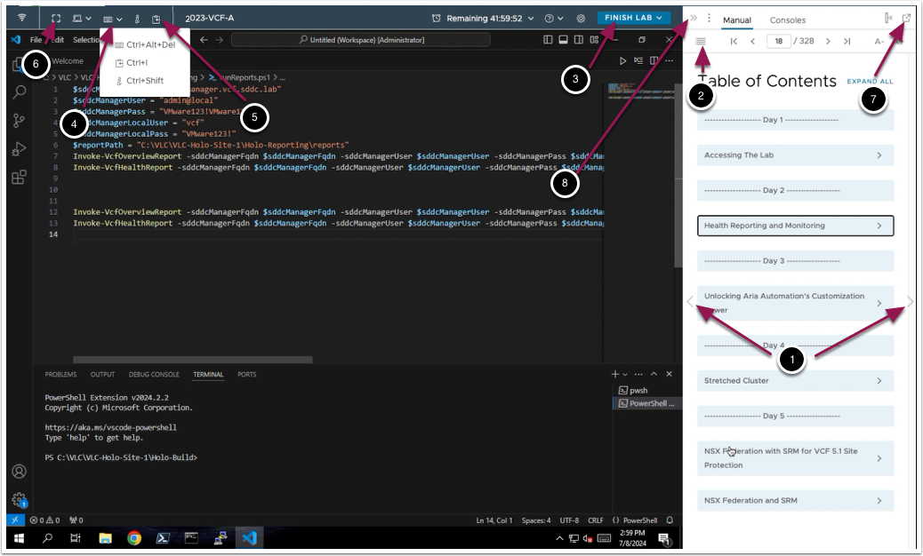

From here you can:

1. Click to advance to the next page and continue with the next lab module
2. Open the TABLE OF CONTENTS to jump to any module or lesson in this lab manual
3. Exit your lab and come back and resume it again in the future
4. Send Ctrl+Alt+Del to the console
5. Send Text into (Paste) the console
6. Enter Full-Screen
7. Detach the Lab Manual
8. Collapse the Lab Manual

## You are ready....is your lab?

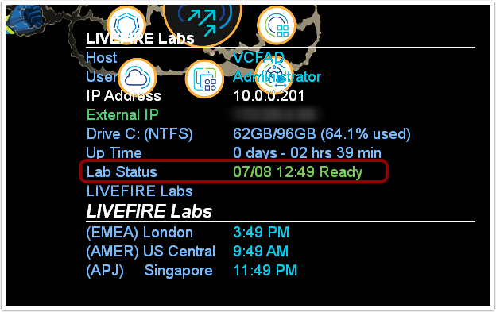

The lab console will indicate when your lab has finished all the startup routines and is ready for you to start. If you see anything other than "Ready", please wait for the status to update.  If after 5 minutes your lab has not changed to "Ready", please ask for assistance.

## How to Copy from manual and Paste into Console

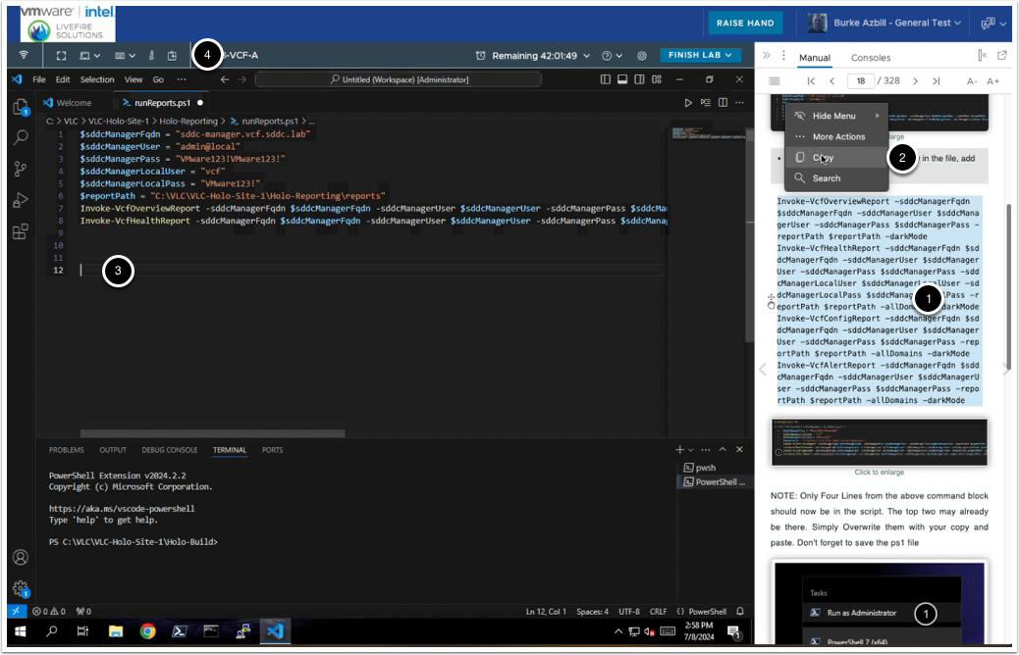

1. Use your mouse to select the text you wish to copy
2. When you release the mouse button to complete your selection, a context menu shows up - Click CopyNOTE: Right click on selected text DOES NOT bring up a copy option and CTRL+C/CMD+C does not work
3. Place your cursor/prompt at the location you wish to paste inside the console
4. Click the Clipboard icon to bring up the "Send text to console" window

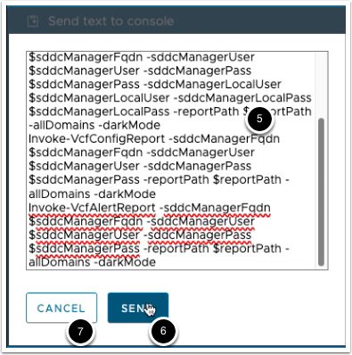

1. Paste the contents of your clipboard into the window using Right-Click -> Paste, or your OS Keyboard combination of either CTRL+V or CMD+V
2. Click the "SEND" button to send the text to the console
3. Click the "CANCEL" button when you are done sending text to the console. This will close the popup window

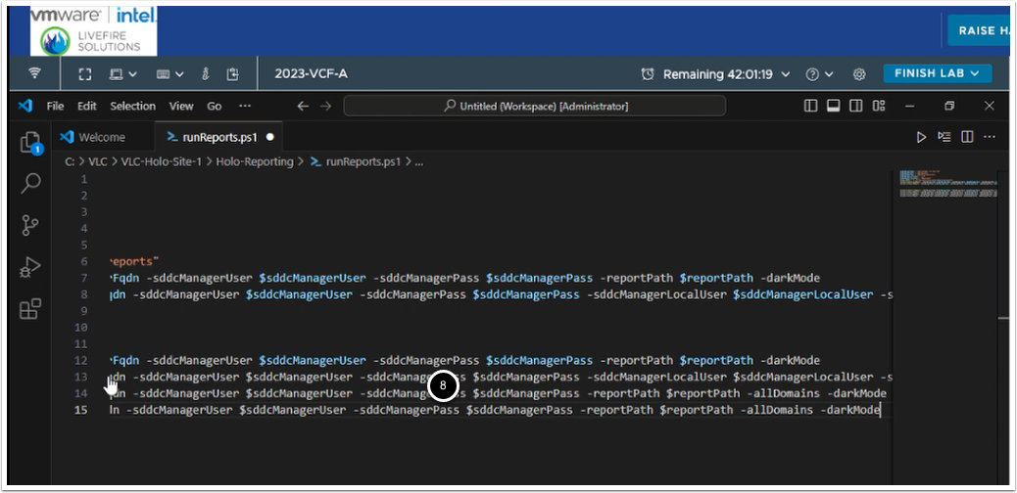

1. Confirm that your pasted text is at the desired location

## Health Reporting and Monitoring 5.2.1

* 1. Overview
* 2. The SoS Utility - Where Operations gets it's HRM Data
* 3. Use the PowerShell/Python Module Locally for VMware Cloud Foundation Reporting
* 4. Prepare for the VMware Cloud Foundation Health Reporting and Monitoring Solution
* 5. Configure the Host Virtual Machine for Health Reporting and Monitoring for VMware Cloud Foundation
* 6. Configure VMware Aria Operations for Health Reporting and Monitoring for VMware Cloud Foundation
* 7. Optional - Add Physical Location to Operations

## 1. Overview

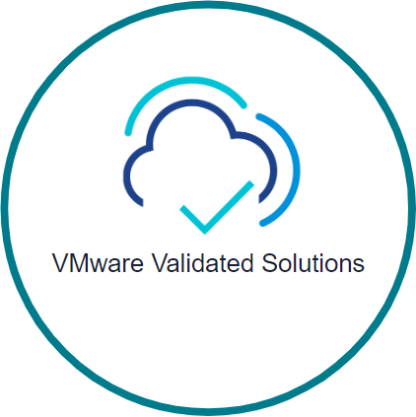

VMware Validated Solutions are a Use-case driven, fully validated, VMware technical design which can be rapidly implemented by customers on VMware Cloud Foundation. In this lab you are going to implement VMware Cloud Foundation Health Reporting and Monitoring based on the VMware Validated Solutions Documentation, which can be found here. Have a look if you are not familiar.

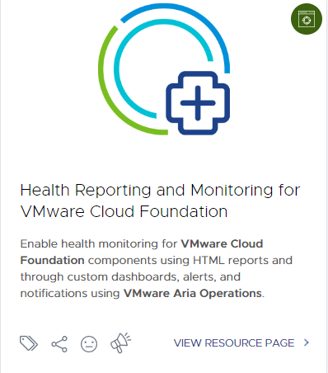

As with all the VMware Validated Solutions  Documentation the VMware Cloud Foundation Health Reporting and Monitoring VVS strives to provide best practice decisions around placement, solution architecture, customer hand off/knowledge transfer, etc.

For the purposes of this Hands On Lab we will focus on the following workflow. Which of course comes directly from the VVS Documentation.

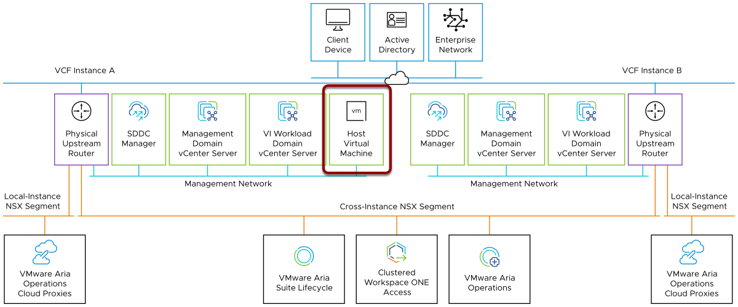

Source: here

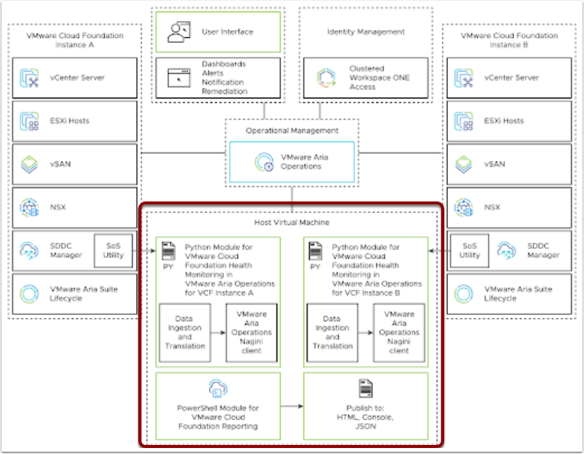

Source: here

In the two diagrams above you will see the basic architecture design. And a closer look inside the Host Machine/Collector Node that provides the VCF Eco System data capture and push into Operations

Enough background Time for the Fun Part

## 2. The SoS Utility - Where Operations gets it's HRM Data

As shown in the previous section the VMware Cloud Foundation Health Reporting and Monitoring Solution makes use of the "SoS Utility"

The Support-ability and Serviceability (SoS) Utility is a command-line tool that you can use to run health checks, collect logs for VMware Cloud Foundation components, and so on. To run the SoS utility, SSH in to the SDDC Manager appliance using the vcf user account.

This lab is just a simple intro, the Health Reporting and Monitoring solutions uses the same APIs and sources to gather it's data before it is sent to Operations to be used with the VCF HRM Management Pack. Knowledge of how to access and use the SoS Utility is a good place to start if you need trouble shoot the Operations HRM Managment Pack for your customer.

At the wrirting of this manual the latest doc on the SoSUtility can be found at



https://docs.vmware.com/en/VMware-Cloud-Foundation/5.1/vcf-deploy/GUID-10BA552D-FE25-4DF4-AFCA-F8A520DD881C.html

## SSH to the SDDC-Manager

You can use the labs resources to do a quick primer on the SoS Utility.

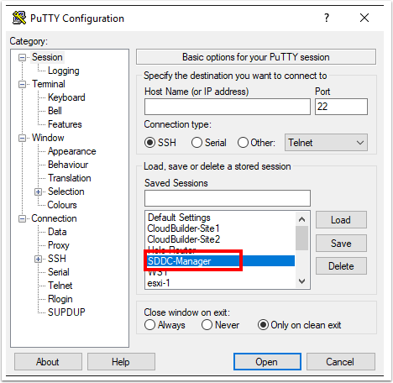

Open PuTTY, Double Click the SDDC-Manager Entry.

SSH keys are in place so you should auto log in

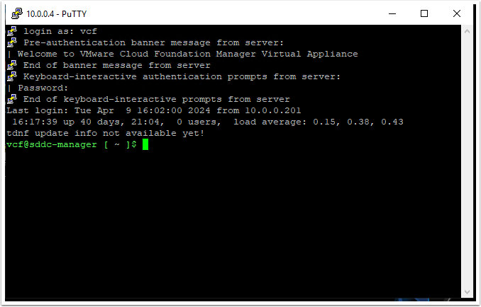

cd to the sddc-support directory

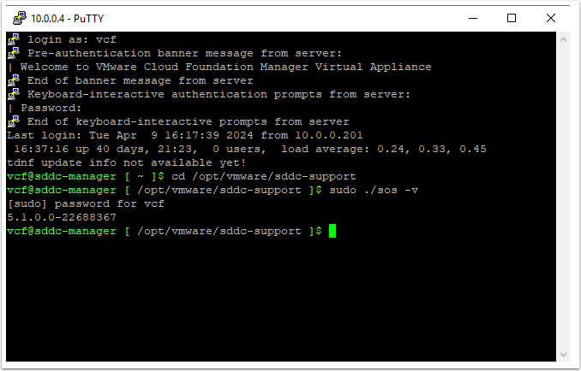

run a quick test to make sure you are in the right directory and the SoS utility is present

Enter the vcf password

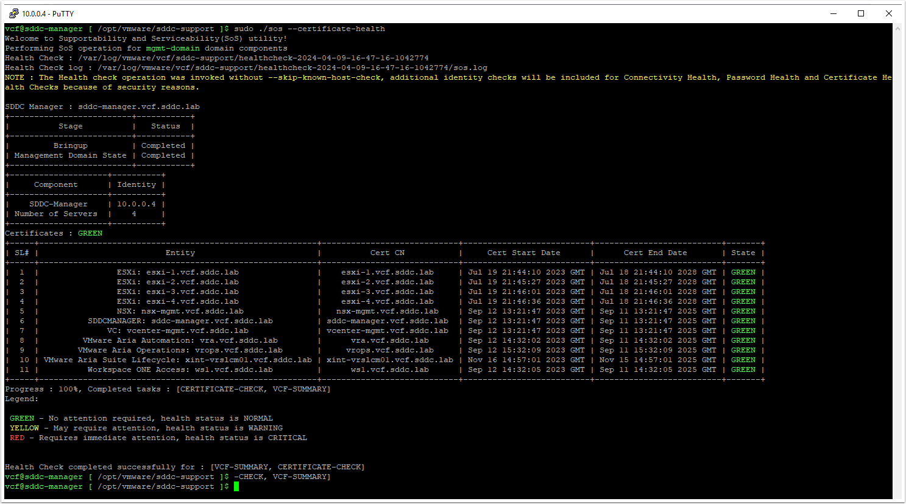

You might want to expand the putty window out a bit, the data that will come back from the SoS utility can be somewhat wide

From the doc you can learn how to use the SoS Utility to gather and export data from the sddc manager, and export that data to logs, json, etc. From the very top of the list of checks, you are going to run the certificate-health check, which verifies that the component certificates are valid (within the expiry date).

To do so simply Run this command

Spend some more time in the SoS Utility doc, work through some use cases you can think of. You can get a better understanding of what data the VCF HRM Management Pack for Operations can supply, where it comes from and how to start troubleshooting if the Pack is not performing as expected. One common issue we in Livefire hear from the field is how long the data can take to come back. This lab is small, it only has 4 hosts in Site 1. The simple example shown takes around 55 seconds to come back. Imagine if the customer has 50, 100 or more hosts. These health checks will take quite a while to run. This needs to be taken into consideration while setting up and relying on the VCF HRM Management Pack for Operations.

Move onto the next section of the lab, where you will use VVS provided Powershell Scripts to run the same API calls into VCF and export the data into a static Local HTML Report.

## 3. Use the PowerShell/Python Module Locally for VMware Cloud Foundation Reporting

## Local Reports

As stated earlier the VMware Cloud Foundation Health Reporting and Monitoring Solution enlists a "Host Machine/Collector Node" that is used for the data integration between VCF and Operations. The data extract tools are based in Powershell and Python

In this part of the lab we wanted to demonstrate how you can pull these scripts locally and use them to run useful reports manually. We have pulled these scripts down for you to the Windows Holo-Console Jumpbox you have RDPed to

## Review and Modify Report Configuration

To get started, on the Holo-Console

* Open the Windows Explorer and navigate to c:\VLC\VLC-Holo-Site-1\Holo-Reporting
* Right click runReport.ps1 and click Open with Code. This file shows all the environment variables needed by the reporting module to deliver reports.

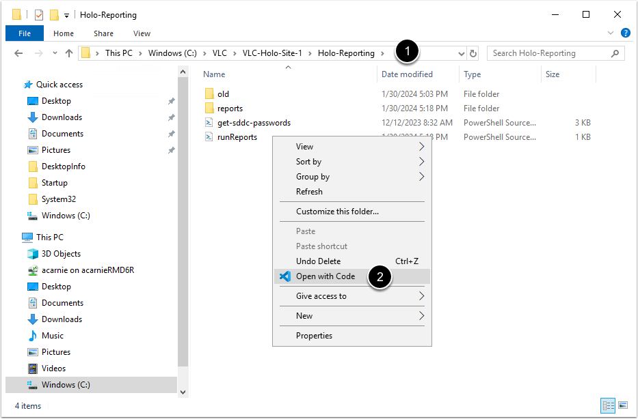

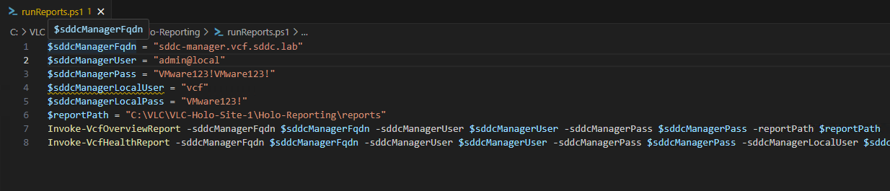

* If the following lines are not already in the file, add them to the file and save it.

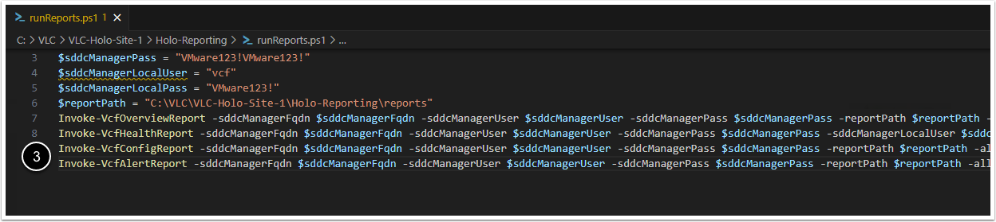

NOTE: Only Four Lines from the above command block should now be in the script. The top two may already be there. Simply Overwrite them with your copy and paste. Don't forget to save the ps1 file

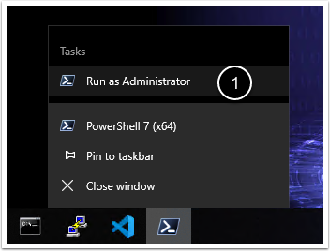

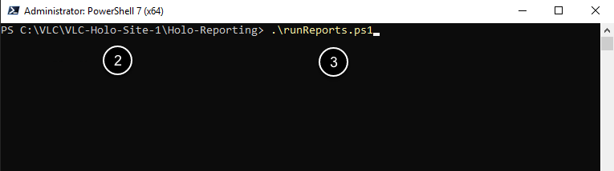

* Within Holo-Console, open a PowerShell window as administrator
* Change directory to C:\VLC\VLC-Holo-Site-1\Holo-Reporting
* Type  .\runReports.ps1 and press enter

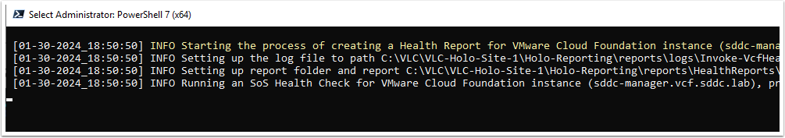

You can monitor the progress of the reporting scripts by viewing the PowerShell Window.

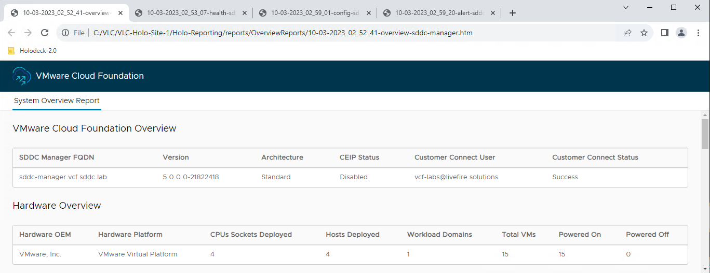

* The output will be displayed as a series of web pages that open automatically in Chrome.  It will take around 6 minutes for all the reports to open.  Take some time to review the content of the reports.  This is useful information when you are preparing for an upgrade, reviewing an existing deployment, or creating documentation for a new deployment.

## How to get the VVS Scripts

At the writing of this lab the doc for the HRM VVS can be found at - https://techdocs.broadcom.com/us/en/vmware-cis/vcf/vvs/1-0.html

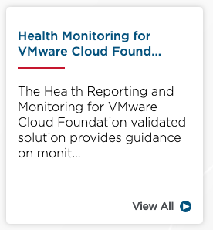

Click the Health Reporting and Monitoring for VMware Cloud Foundation Box, which takes you to -  https://techdocs.broadcom.com/us/en/vmware-cis/vcf/vvs/1-0/health-reporting-and-monitoring-for-vmware-cloud-foundation.html

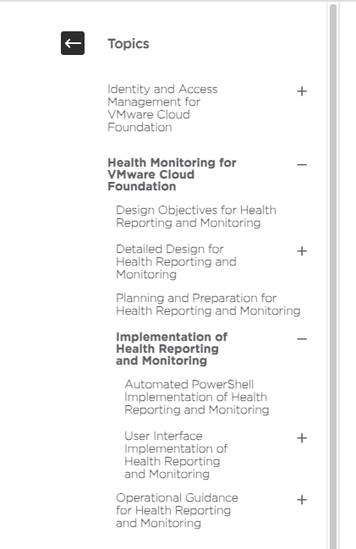

To get to the doc on how to get these scripts in both Powershell and Python can be found click the Implementation - Health Reporting and Monitoring Box, which takes you to - https://techdocs.broadcom.com/us/en/vmware-cis/vcf/vvs/1-0/health-reporting-and-monitoring-for-vmware-cloud-foundation/implementation-for-health-monitoring.html

This page will guide you on all the Prerequisites for Installation of Open-Source Software of Health Reporting and Monitoring for VMware Cloud Foundation for both powershell and python.

It's from here that you move on to integrating these reports to Operations, and moving them from a local "static" type tool and making them part of your customer Operations Eco System and all the benefits that brings.

Move on to the next section on the lab

## 4. Prepare for the VMware Cloud Foundation Health Reporting and Monitoring Solution

## Assign SDDC Manager Role to a Service Account for the PowerShell Module for VMware Cloud Foundation Reporting

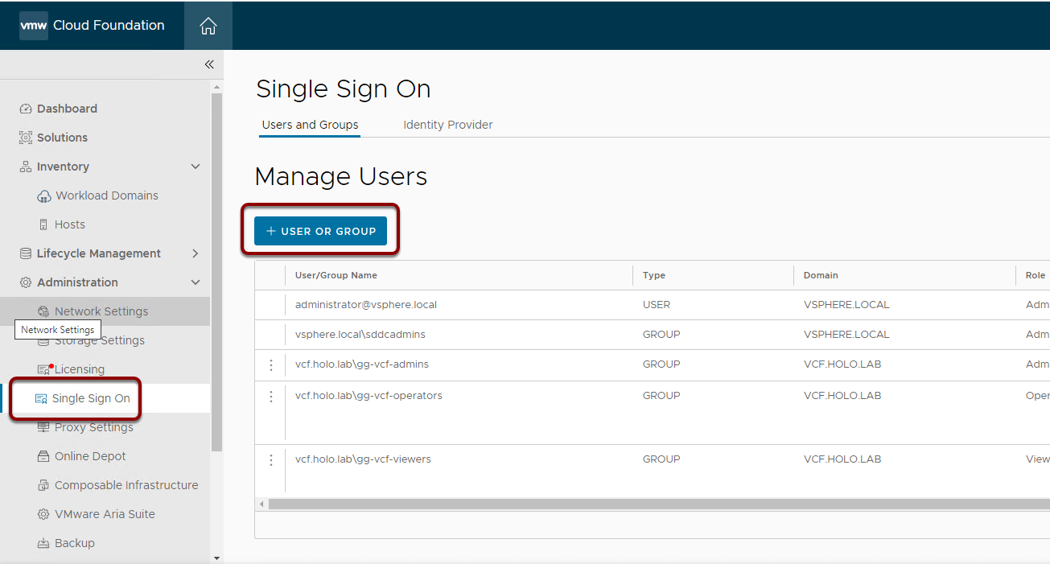

LogIn to https://sddc-manager.vcf.sddc.lab/

click Administration > Single sign on.

click Add user or group.

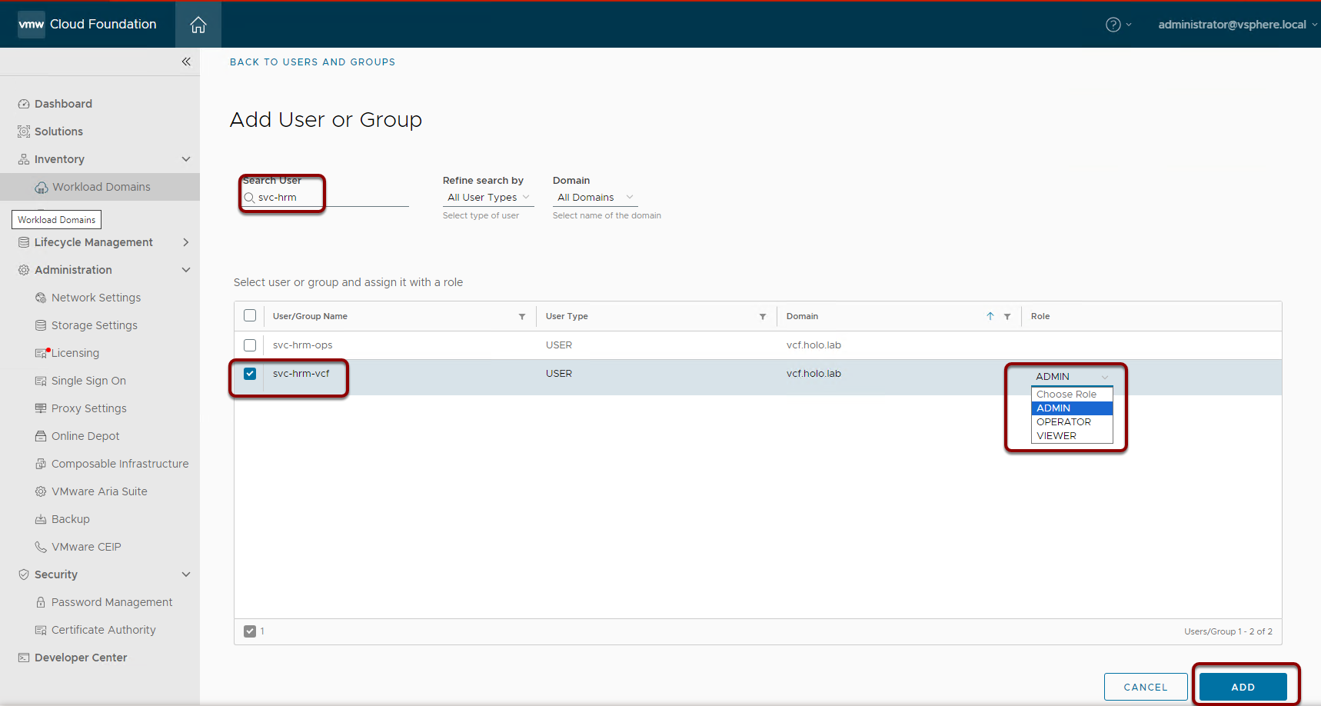

Enter svc-hrm in the search User field

Select the svc-hrm-vcf account

Set The Role to ADMIN

Click ADD

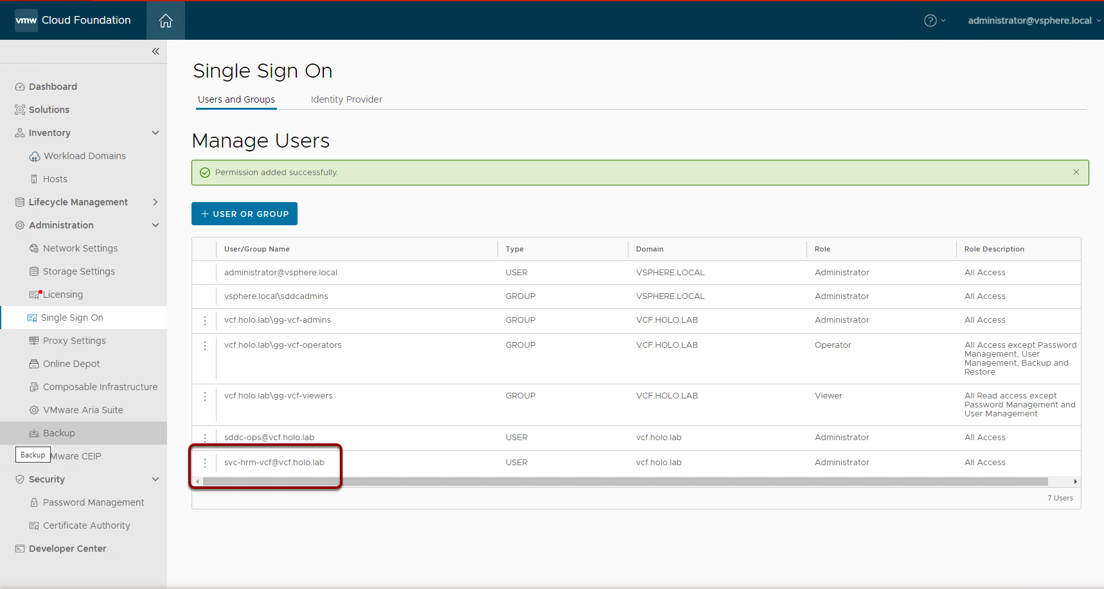

The new Service is added.

## Define a Custom Role in VMware Aria Operations for the Python Module for VMware Cloud Foundation Health Monitoring

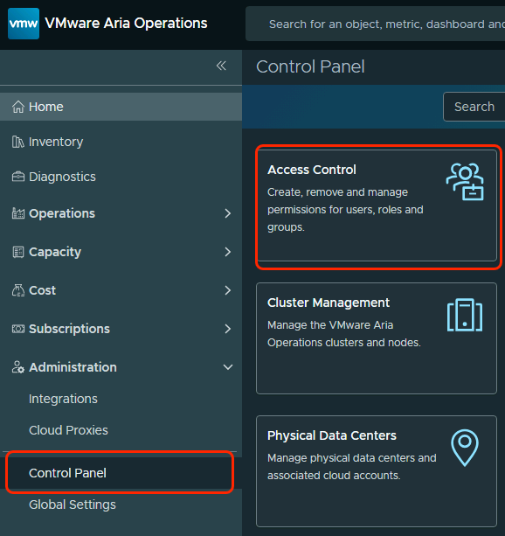

* Log in to the VMware Aria Operations interface at https://vrops.vcf.sddc.lab/ a user assigned the Administrator role
* In the left pane, click Control Panel.
* Click Access control

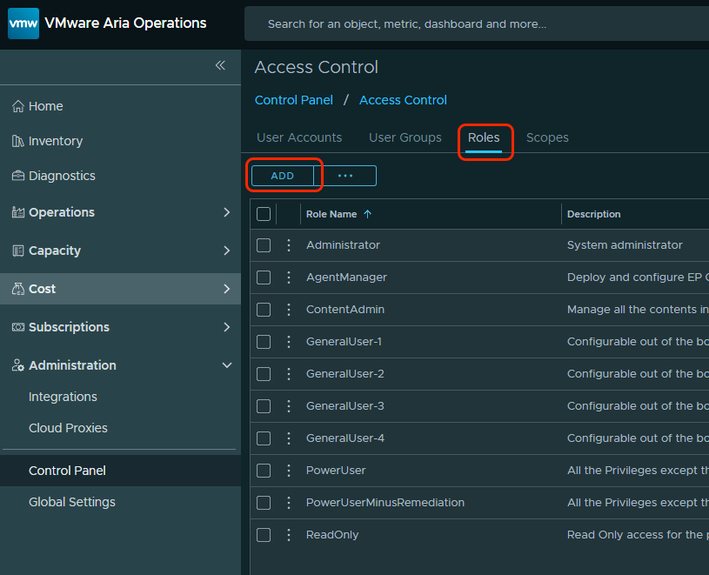

* Click the Roles tab.
* Click Add

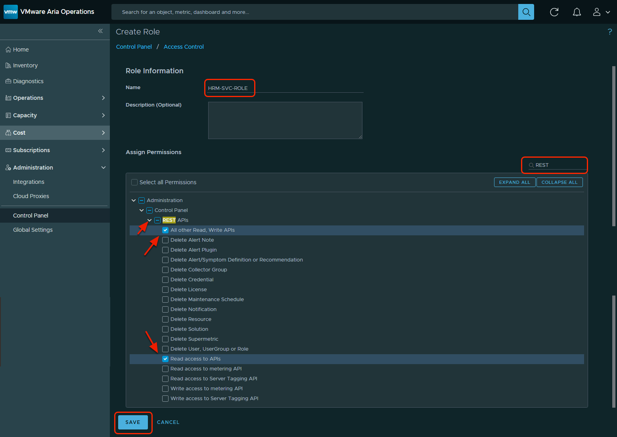

* Configure the new custom role and assign access control scope.  
  Give the new Role a name. i.e. HRM-SVC-ROLE  
    
  On the Create Role page in the Role information section, configure the Assign Permissions according to the values in the table below.  
  In the Assign permissions section, configure the settings according to the values in the table below and click Save.
* Give the new Role a name. i.e. HRM-SVC-ROLE
* On the Create Role page in the Role information section, configure the Assign Permissions according to the values in the table below.
* In the Assign permissions section, configure the settings according to the values in the table below and click Save.

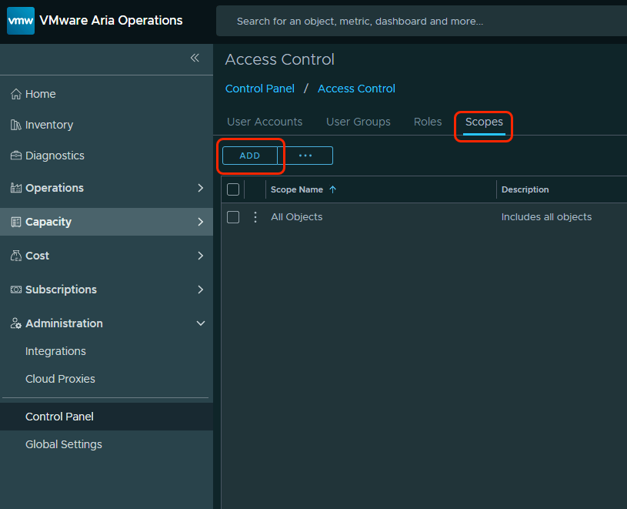

* On the Access control page, click the Scopes tab.
* Click ADD

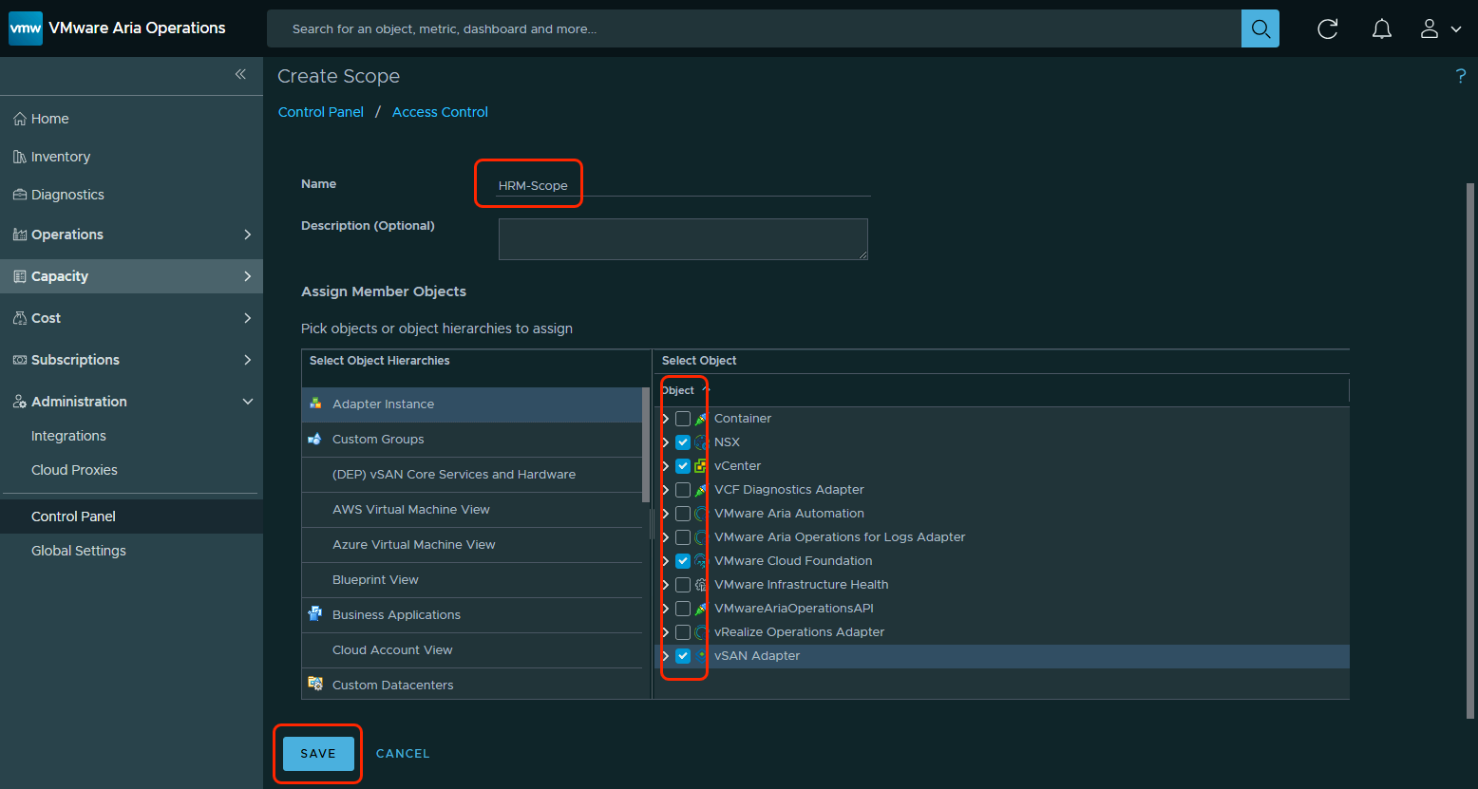

On the Create scope page in the Scope information section.

Give the new Scope a name, i.e. HRM-Scope.

Configure the Assign Member Objects according to the table below, click Save

## Assign VMware Aria Operations Custom Role to a Service Account for the Python Module for VMware Cloud Foundation Health Monitoring

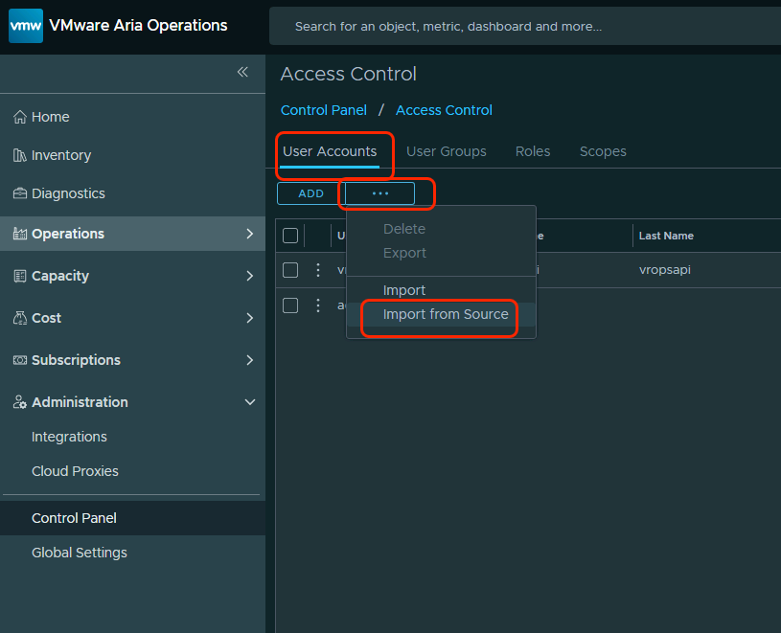

Click the User accounts tab.

Click the Three Dots then Import from Source

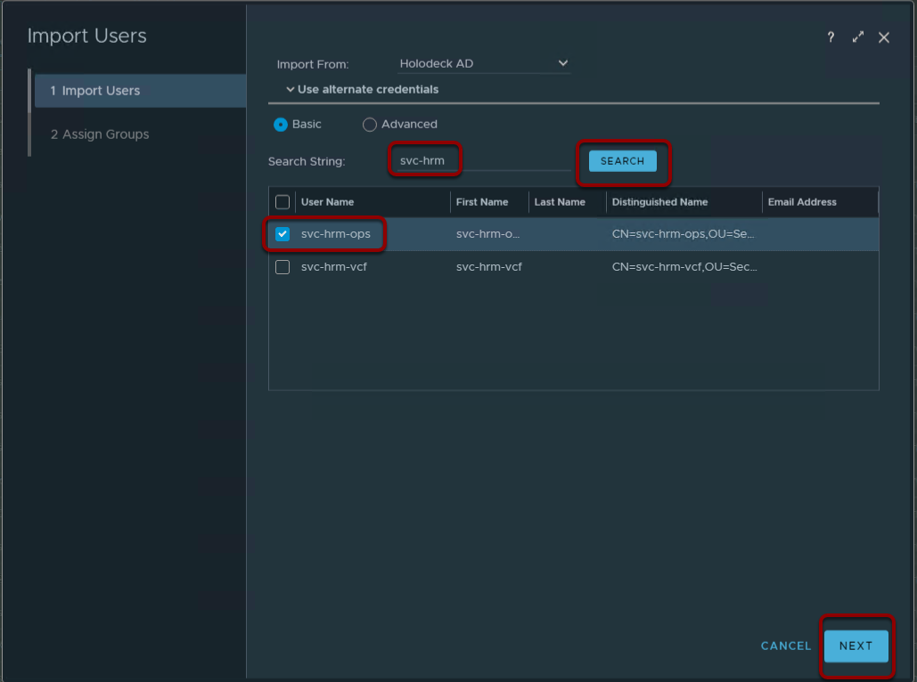

In the Search form enter svc-hrm and click SEARCH

Click the Radio Check Box next to the svc-hrm-ops Service Account

Click NEXT

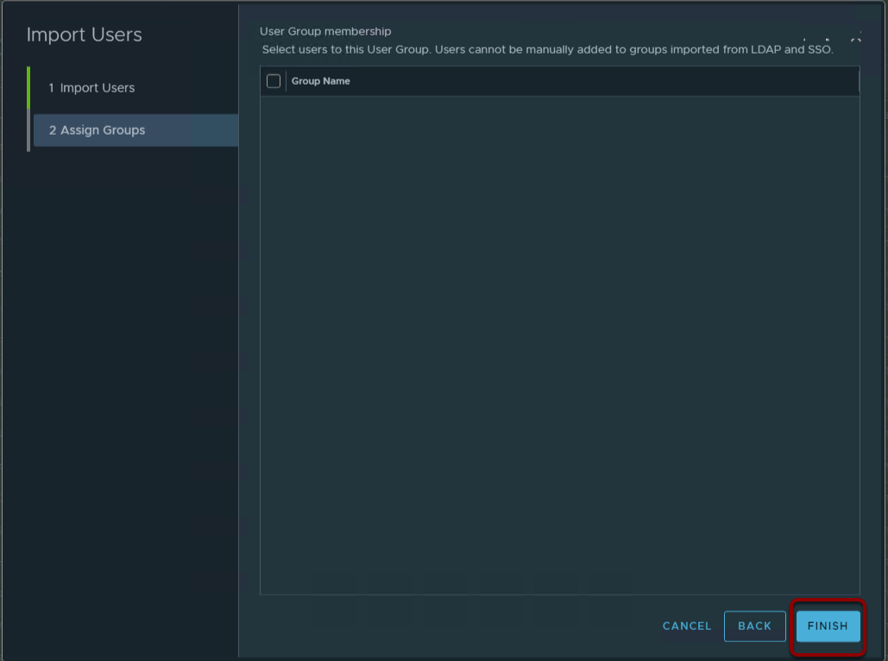

Click FINISH

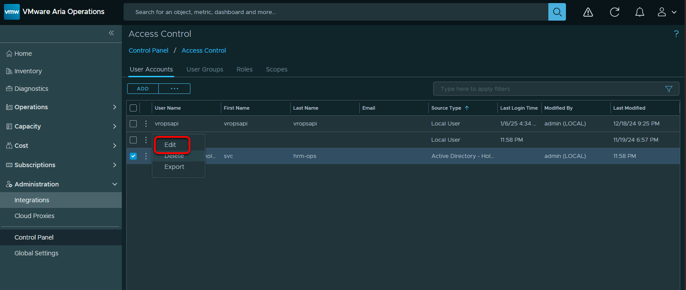

Find the newly imported svc-hrm-ops user, click the three dot next to it and click Edit

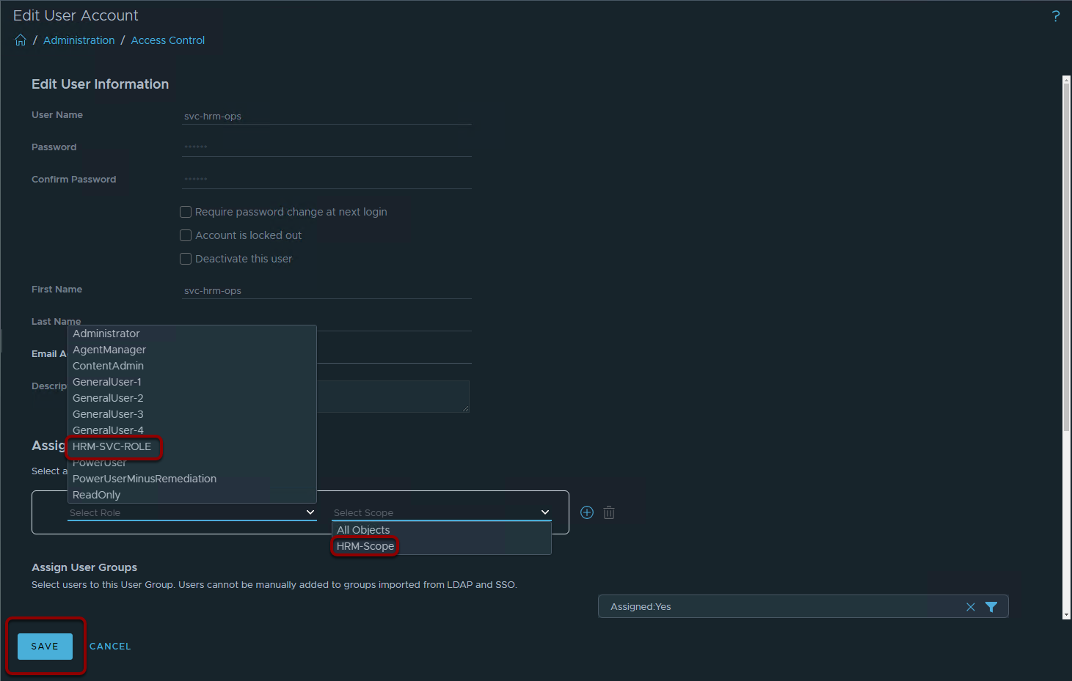

Add the new HRM-SVC-ROLE and HRM-Scope to the svc-hrm-ops user

Click SAVE

## Create Virtual Machine for the Host Virtual Machine for Health Reporting and Monitoring for VMware Cloud Foundation

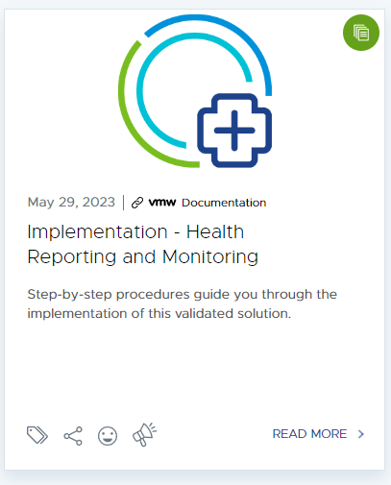

The Health Reporting and Monitoring Validated Solution uses a custom "host machine", Operations Cloud Proxy, also know as a "collector node" to run the data collection scripts and then push the output to Operations.

The "host virtual machine" can be a Photon OS or Windows Server based operating system that adheres to your customer's standards.

For purposes of the lab we will use a sample appliance provided by the VVS team. This appliance comes with all necessary OS packages. If your customer requires you to deploy a host virtual machine based on their specs, you must install the following packages:

* logrotate
* wget
* git
* unzip
* tar
* jq
* cronie
* powershell
* python3-pip

Full documentation for a custom build of the host machine can be found - https://techdocs.broadcom.com/us/en/vmware-cis/vcf/vvs/1-0/health-reporting-and-monitoring-for-vmware-cloud-foundation/implementation-for-health-monitoring/implementation-of-health-reporting-and-monitoring-using-component-user-interfaces/configure-the-host-virtual-machine-for-health-reporting-and-monitoring.html#GUID-DD1B7D6C-F26A-4E03-91F8-04FB0A701E0C-en

## Verify HRM Host machine DNS

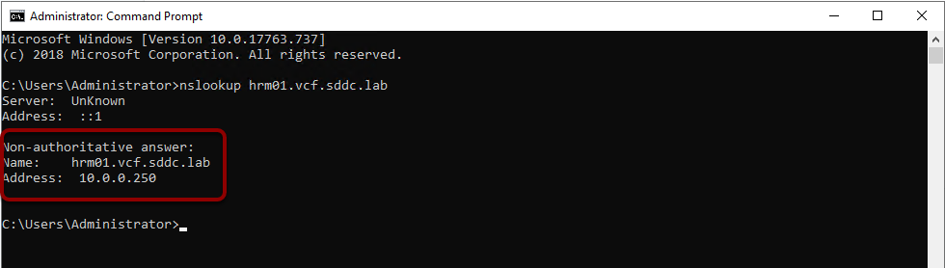

Just to verify DNS is working open a command terminal on the windows jumpbox and run:

When you deploy the VM you will use this IP 10.0.0.250, which is on the management network. This information would come from your planning and preparation workbook/.

## Pull the OVA down to your lab environment.

To save you some time, the VSS team has prepared an Appliance you can simply pull down and deploy. Paste the URL in chrome

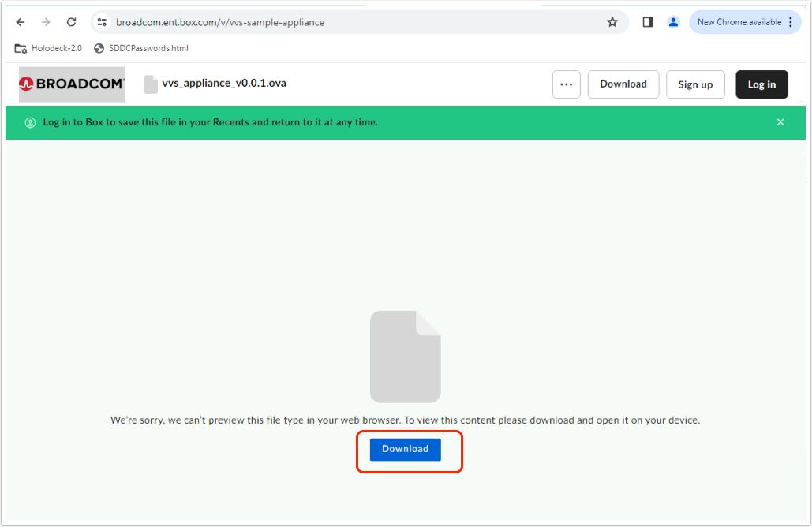

Click Download.

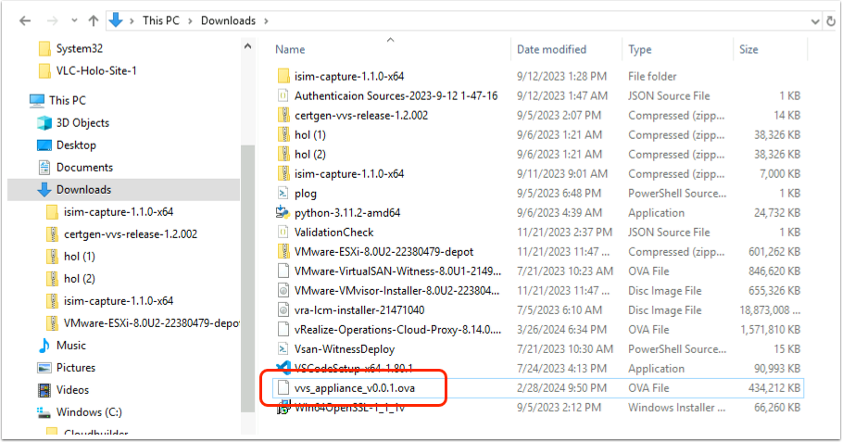

In a few seconds you should have the vvs_appliance_.ova in the "Downloads" directory.

## Deploy HRM host machine to vSphere

Next deploy the Appliance to vSphere.

You all should know how to deploy an OVA to vSphere, but just in case....

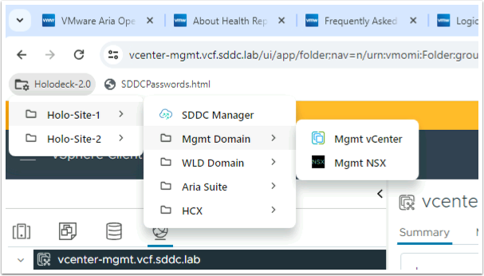

LogIn to the Management Domain vCenter

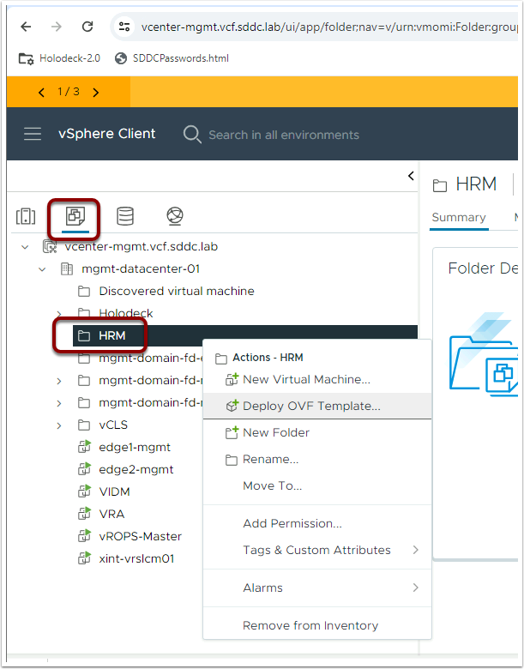

Create an HRM Folder and Deploy OVF Template into it

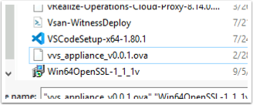

Use the recently downloaded vvs appliance ovf

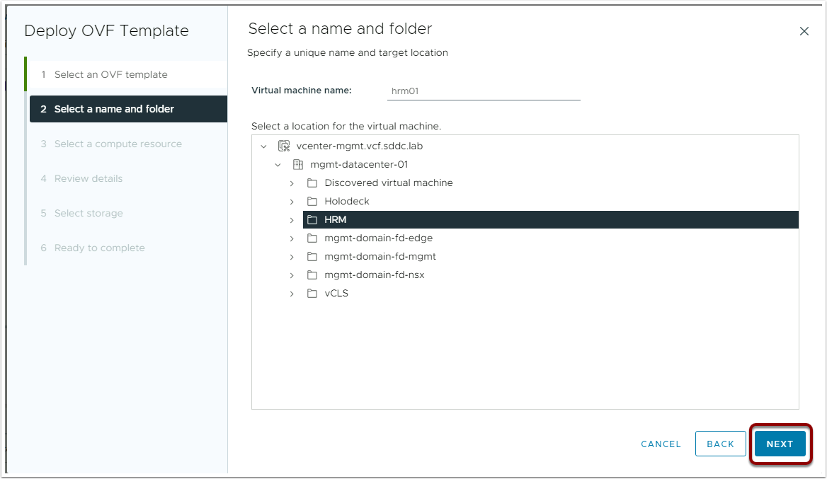

NEXT

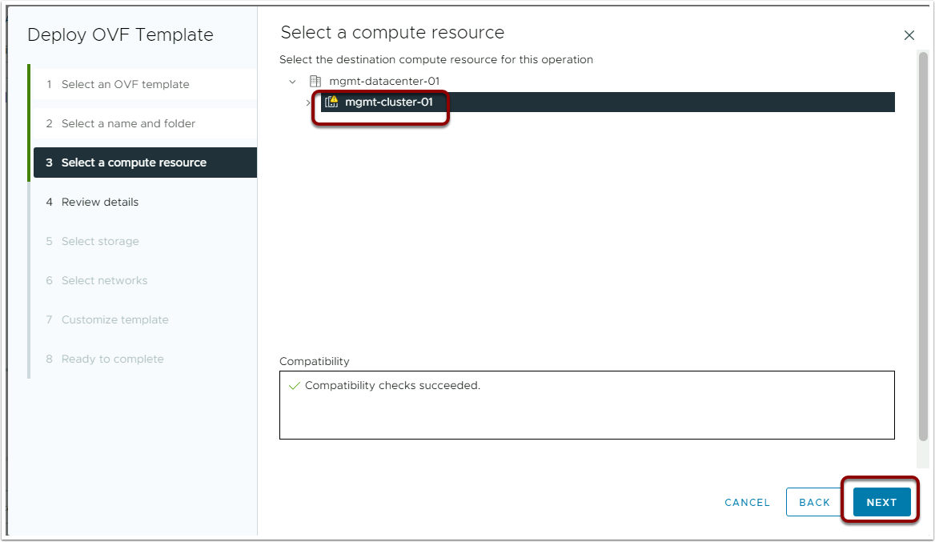

NEXT ... if you are confident

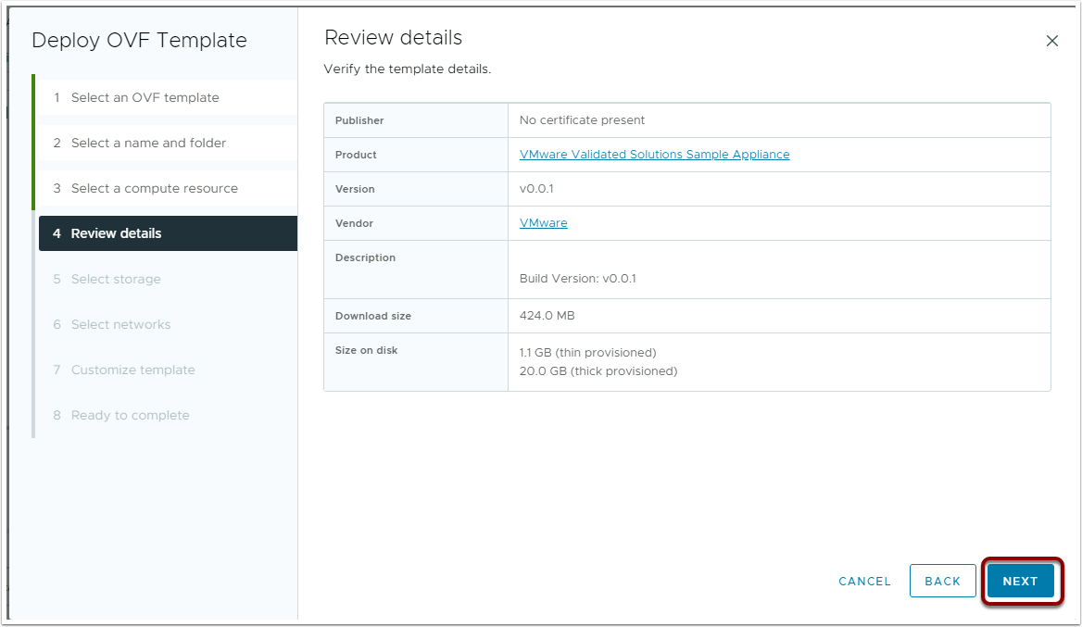

NEXT ...I dare you

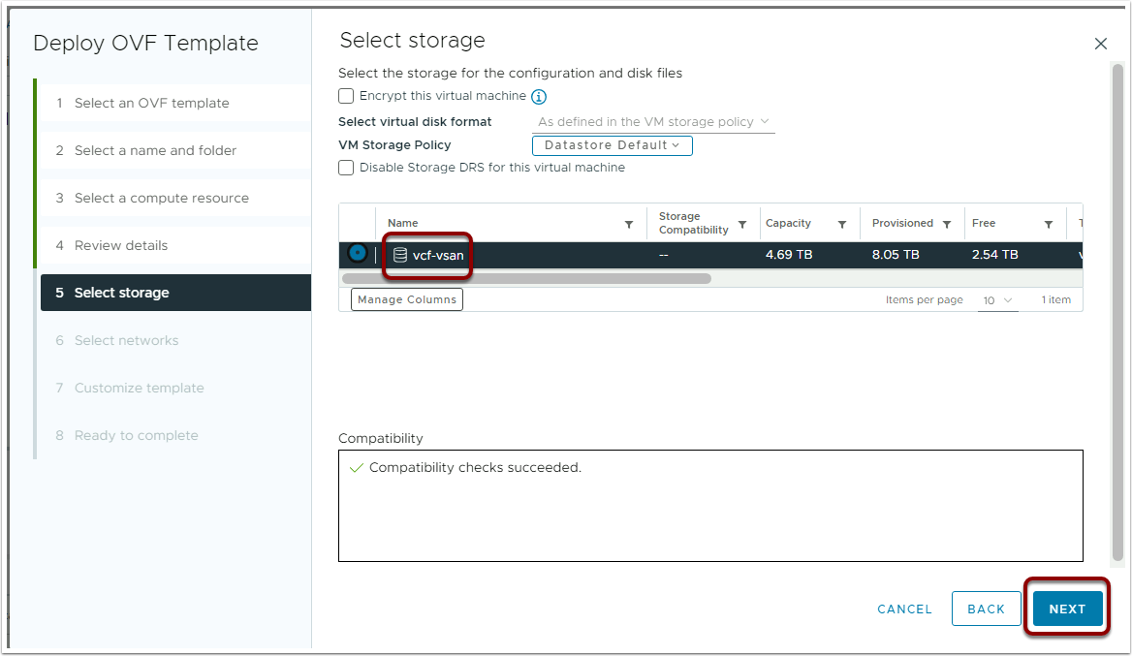

NEXT ...Only One Datastore so easy as it goes

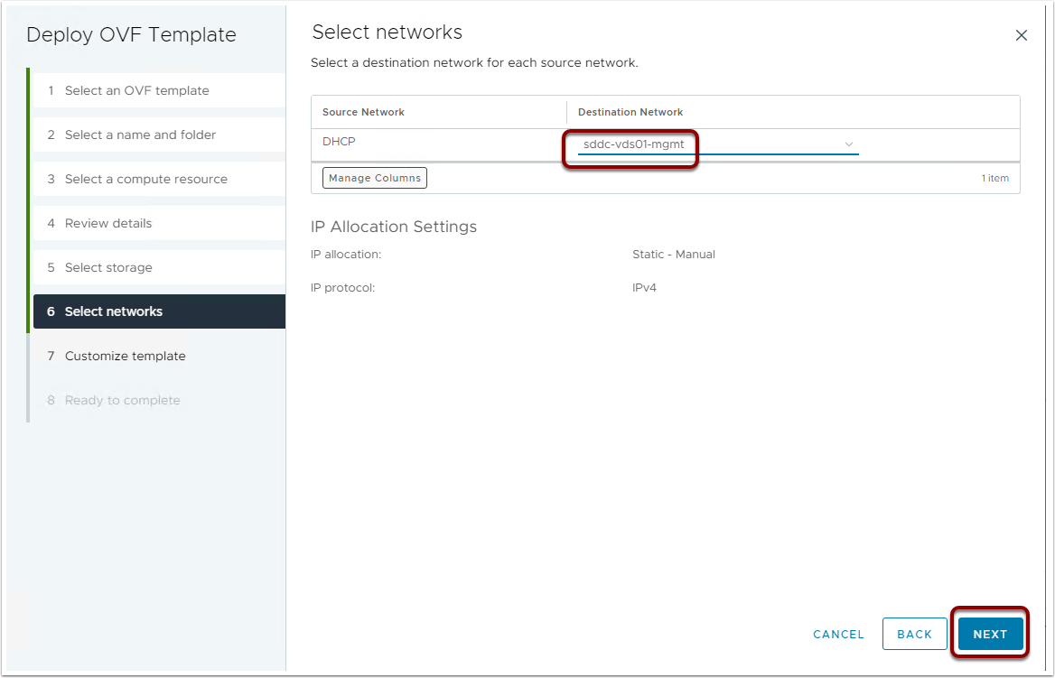

Browse to and choose the sddc-vds01-mgmt network

Oh and NEXT!

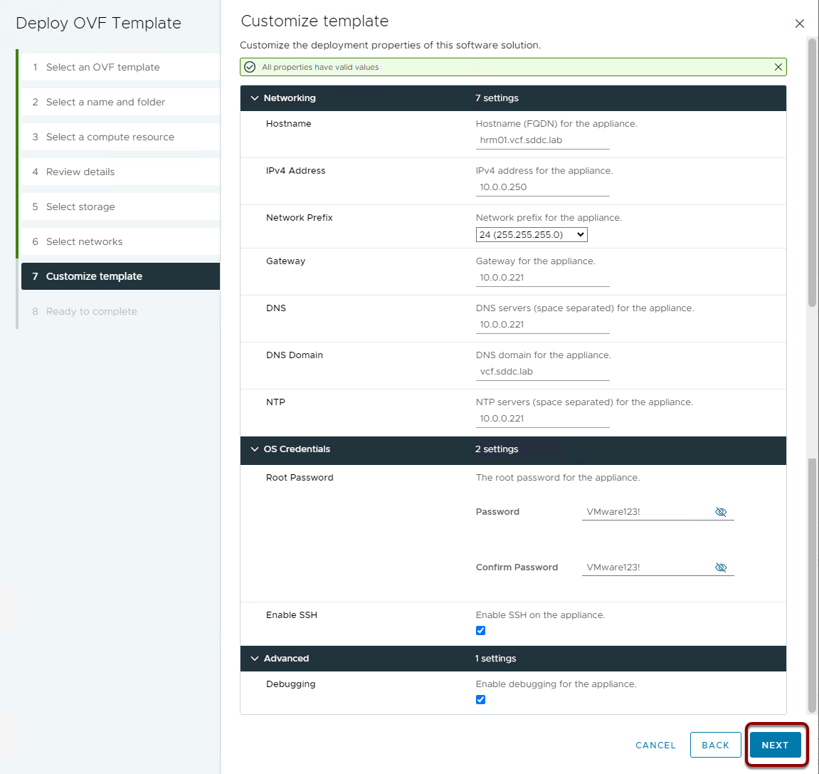

Finally you need to fill in some real data.

This would all come from your Planning and Preparation Workbook

click NEXT ...of course

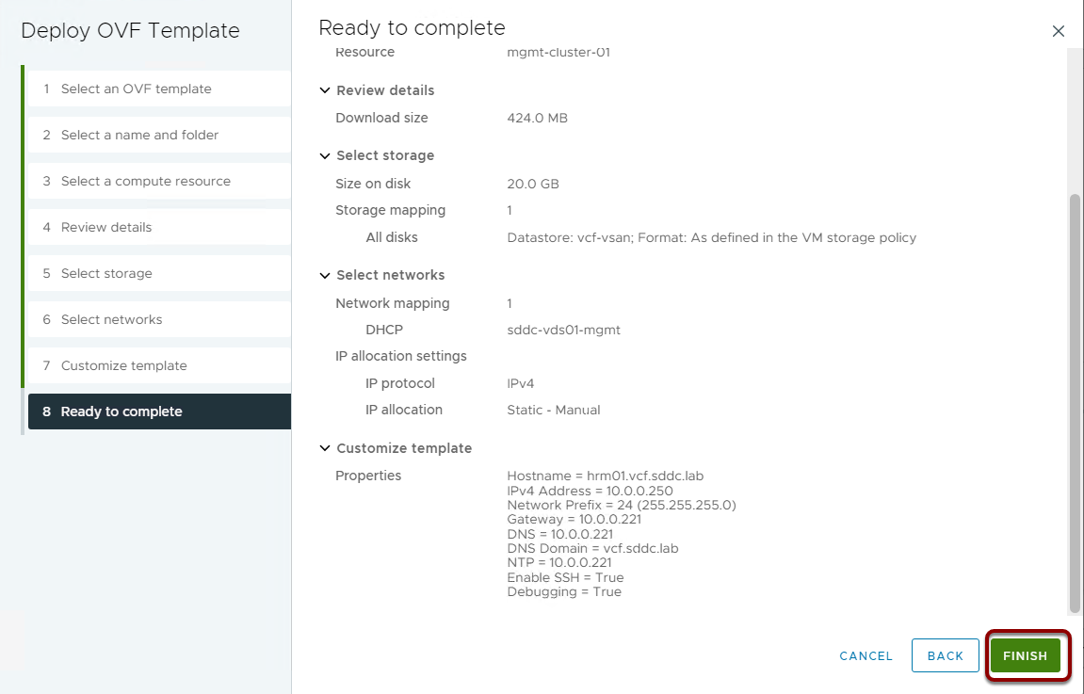

click NE....I mean FINISH

## Host Machine Ready

## 5. Configure the Host Virtual Machine for Health Reporting and Monitoring for VMware Cloud Foundation

## Configure the Host Virtual Machine for Health Reporting and Monitoring for VMware Cloud Foundation

https://docs.vmware.com/en/VMware-Cloud-Foundation/services/vcf-health-reporting-and-monitoring-v1/GUID-DD1B7D6C-F26A-4E03-91F8-04FB0A701E0C.html

## Install the PowerShell Module for VMware Cloud Foundation Reporting

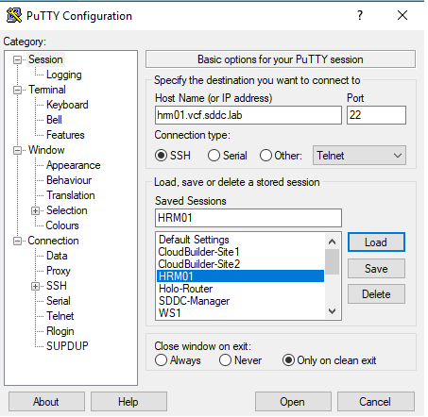

Now that your HostMachine is deployed and booted, open PuTTY, create and save a new entry for for it. Use the FQDN

Give it a display name in PuTTY like HRM01 and save the entry

Use this new entry to Log In to your new HostMachine

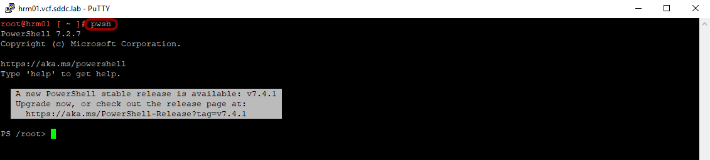

Start Powershell in linux, run

Install the PowerShell module and its dependencies from the PowerShell Gallery by running the commands in the console.

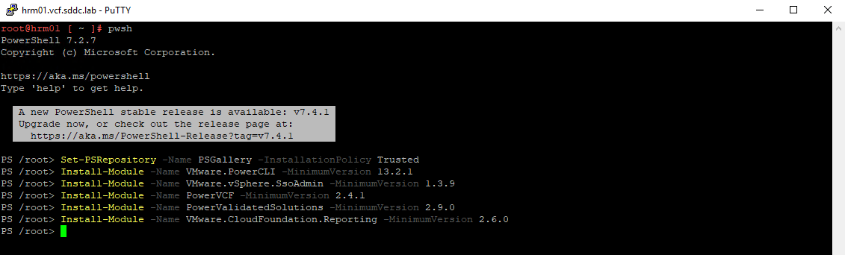

It will take a while to install and if you copy and past from this manual do not forget to hit enter as the last line comes up but may not run. It's waiting for you to hit enter.

Import the modules by running the commands in the console.

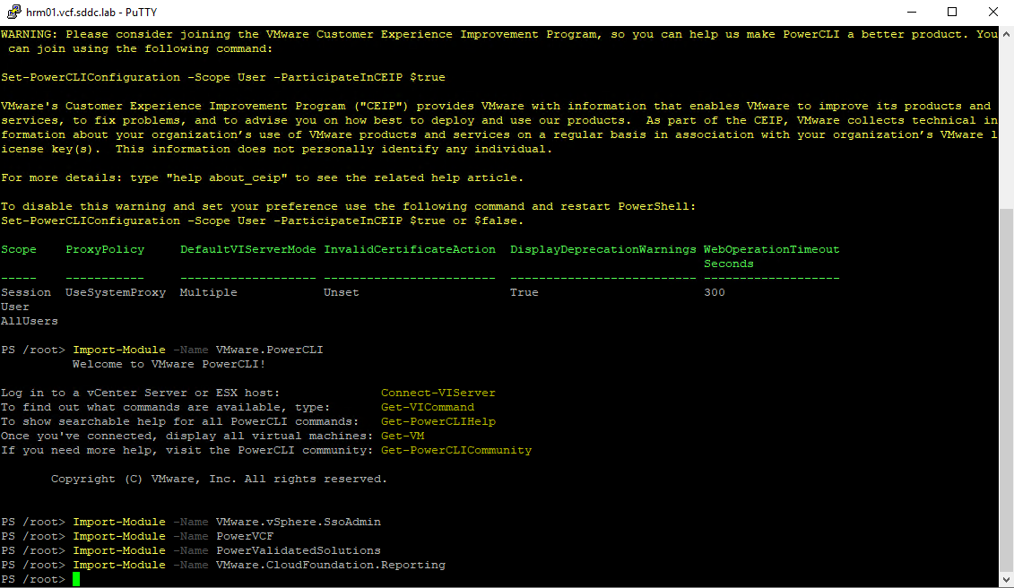

This runs quite quickly

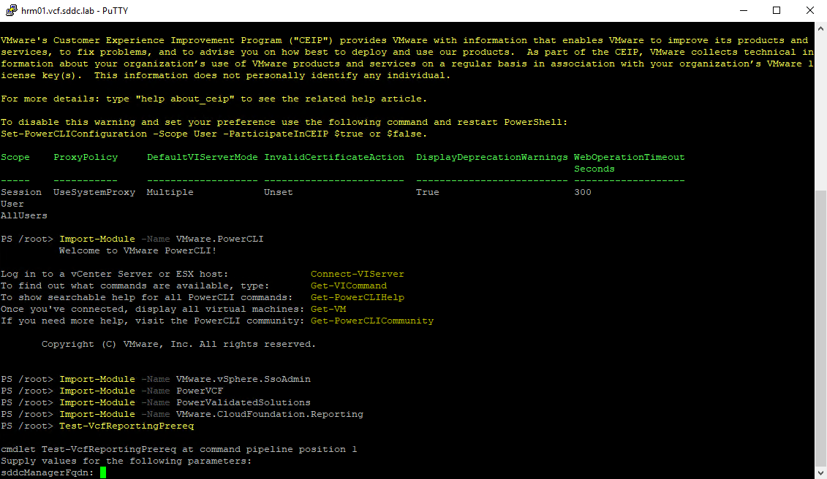

Verify the modules are installed correctly by running the command in the console.

Use the following Values as prompted

sddcManagerFqdn

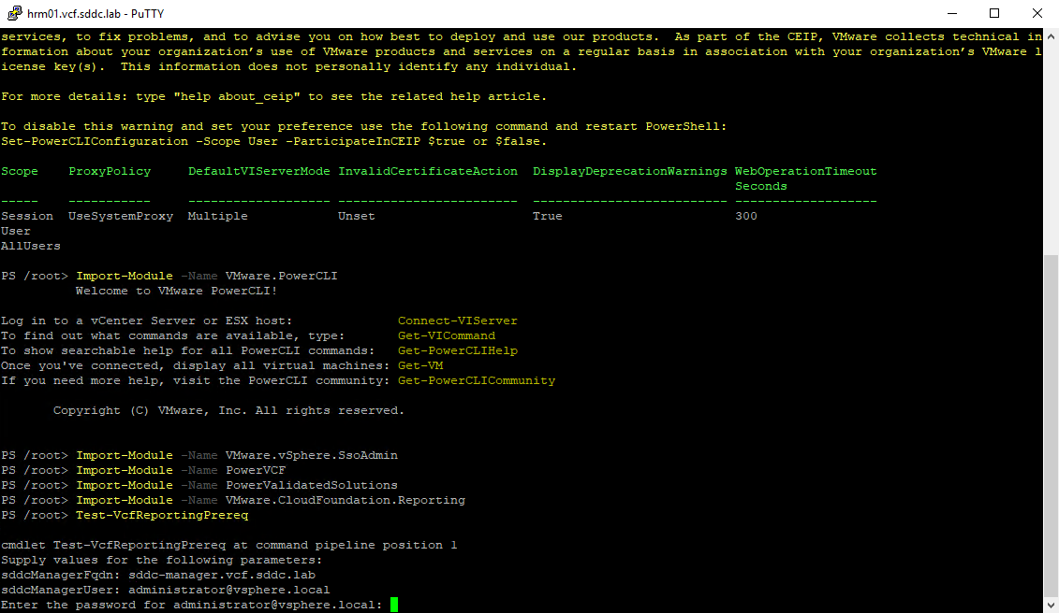

sddcManagerUser

Password for administrator@vsphere.local

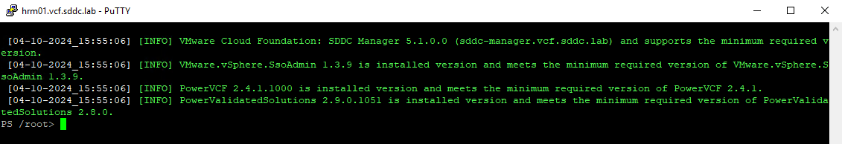

Success

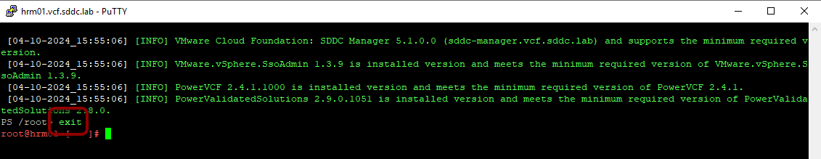

## Install and Configure the Python Module for VMware Cloud Foundation Health Monitoring in VMware Aria Operations

Upload the Python Module for VMware Cloud Foundation Health Monitoring in VMware Aria Operations to the host virtual machine and configure the necessary settings to enable health data collection and the integration with VMware Aria Operations

Install the Python Module for VMware Cloud Foundation Health Monitoring in VMware Aria Operations

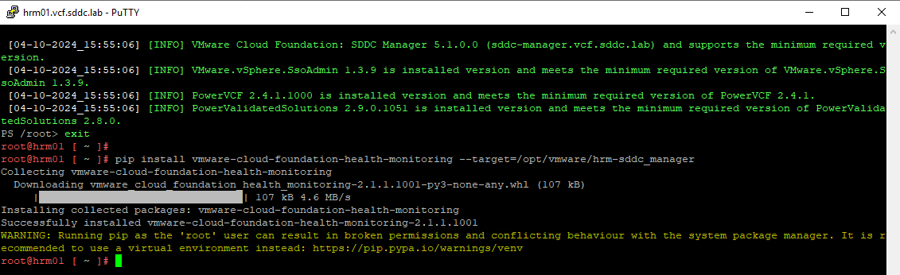

Provide execute permissions to the files in the hrm directory

Switch to the hrm-/main directory.

Now you need to set the environment variables used by the scripts. Run cat against the env.json file to see what needs to change

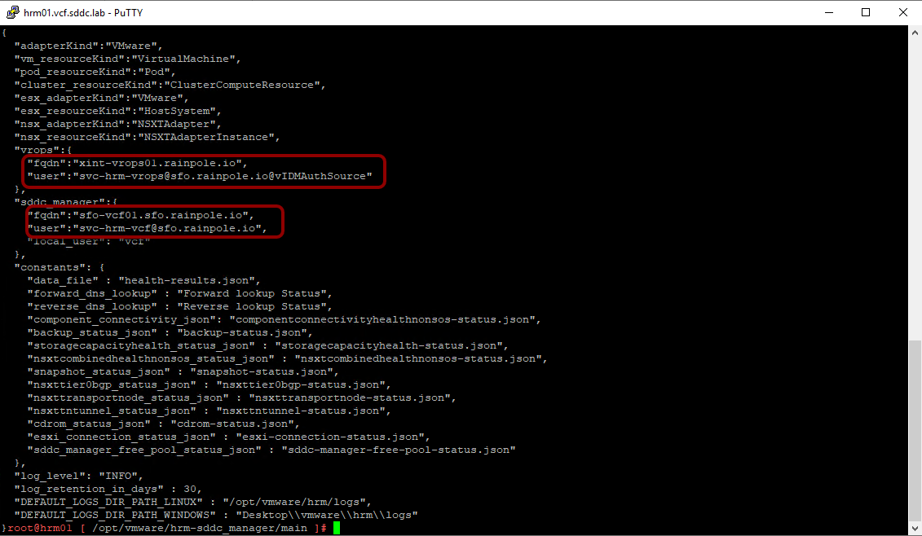

The lines that need to be modified have been highlighted here.

As you are about to make some changes make a backup of the env.json file so you can always reset back to base

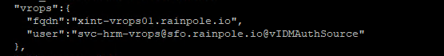

In env.json file provided by the VVS you will see the block above. You need to change the settings for Operations FQDN and the User the scripts will use to connect and push data.

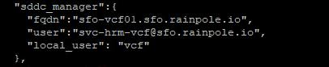

Then the same for the FQDN for the SDDC manager and the Users used to connect and extract data from the SDDC Manager, you will see this block in the supplied env.json file. Changes based on:

Of course you can vi or vim this file and make the changes manually, but since we have sed, and automation is the heart and soul of the VVS, here are the sed commands that should make all the changes for you. Copy and paste the block below

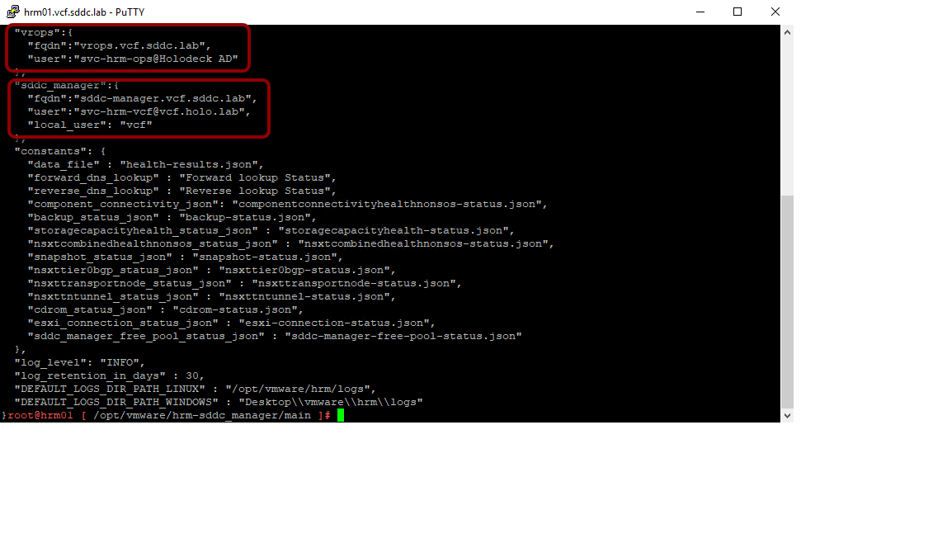

Now we need to set and encrypt the passwords used. Luckily for us the password is VMware123! in the lab.

Run the encrypt-password script

At the Prompt

Enter password for VMware Aria Operations user - svc-hrm-ops@Holodeck AD:

Use password

At the Prompt

Enter password for SDDC Manager user - svc-hrm-vcf@vcf.holo.lab:

Use password

At the Prompt

Enter password for SDDC Manager local user - vcf:

Use password

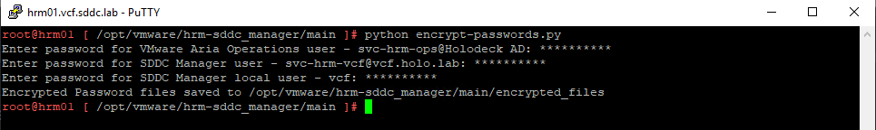

## Install the VMware Aria Operations Nagini Client for Health Reporting and Monitoring for VMware Cloud Foundation

Download the Python language bindings package for VMware Aria Operations

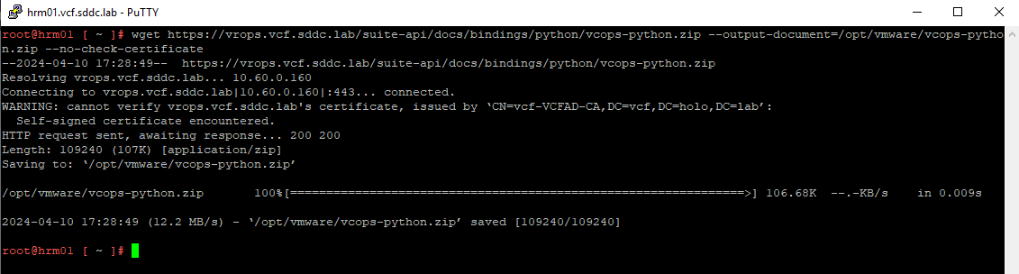

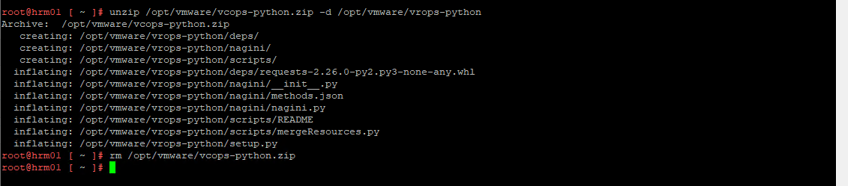

Unzip the Python language bindings package zip file

Navigate to the Python language bindings package directory you previously created

Install the Python language bindings package

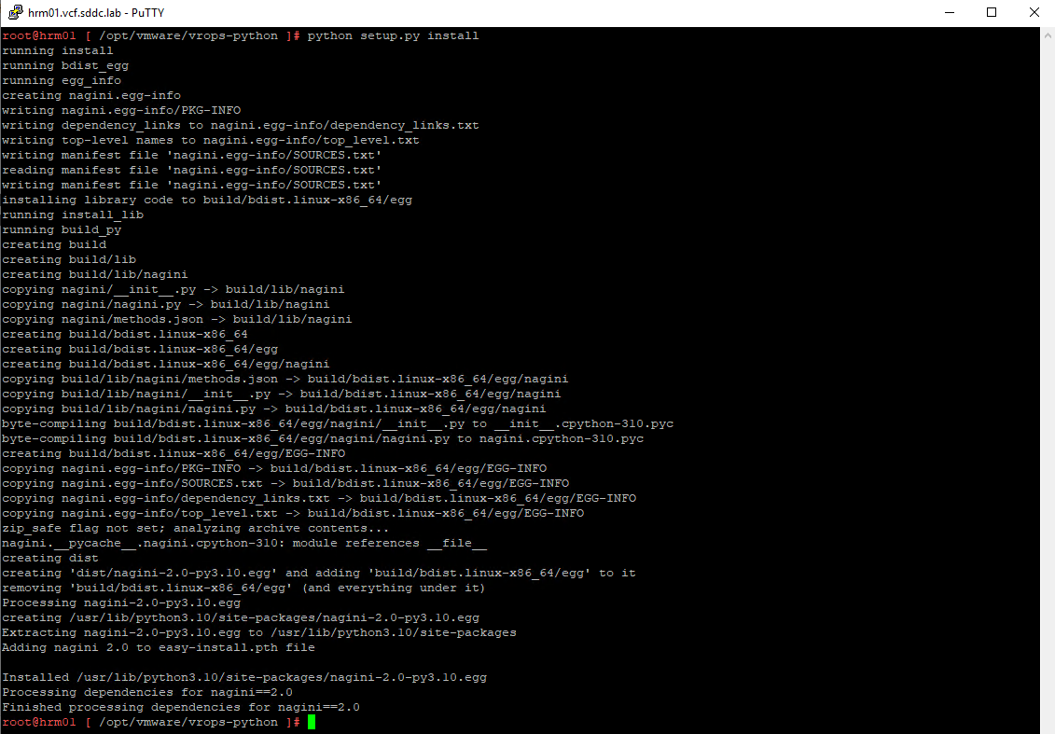

## Manually Run the Python Module for VMware Cloud Foundation Health Monitoring in VMware Aria Operations

Run the send-data-to-vrops.py script for each VMware Cloud Foundation instance.

In the lab of course this is just one instance. But the way this VVS is architected supports sending multiple VCF Instance data to Operations from a single collector

When the script completes, it generates .json report files and logs in the DEFAULT_LOGS_DIR_PATH directory, set in your env.json file. Which is at

If you need to troubleshoot the connections to the SDDC Manager and to Operations

## Schedule the Python Module for VMware Cloud Foundation Health Reporting in VMware Aria Operations to Run Daily

The last part of setting up the host machines is to Automate sending health data to VMware Aria Operations by scheduling the Python module to run daily. We do this with cron.

Edit the cron tab.

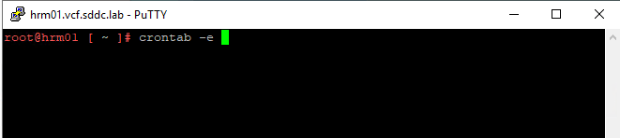

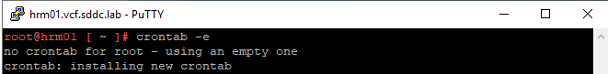

Add the following to the file

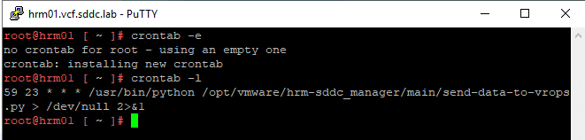

Adjust the cron tab as needed for scheduling of data extract and import. Take into consideration large environments will take quite a while for the data to be extracted and pushed. As well as additional VCF Eco system connections.

The sample cron table entry in the VVS, and this lab, will run every day at 23:59.

With that done the last step is to import the pieces of the Health Reporting and Monitoring management pack into Operations.

Move on to the next section

## 6. Configure VMware Aria Operations for Health Reporting and Monitoring for VMware Cloud Foundation

After you deploy and configure the host virtual machine with the PowerShell Module for VMware Cloud Foundation Reporting and the Python Module for VMware Cloud Foundation Health Monitoring in VMware Aria Operations, you import and configure views, super metrics, dashboards, alerts, and notifications in VMware Aria Operations to enable health data ingestion and aggregation.

You must enable super metrics in the default policy of VMware Aria Operations.

The artifacts you will need to accomplish this reside in the target directory you selected when you installed the Python Module for VMware Cloud Foundation Health Monitoring in VMware Aria Operations by using PiP.

https://docs.vmware.com/en/VMware-Cloud-Foundation/services/vcf-health-reporting-and-monitoring-v1/GUID-4247C0E9-656F-4B7E-9801-820C6F435A88.html

## Import and Configure Artifacts in VMware Aria Operations for Health Reporting and Monitoring for VMware Cloud Foundation

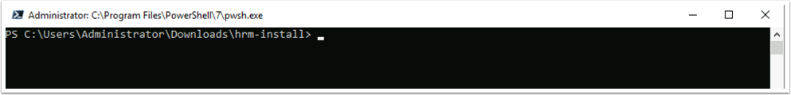

Open a terminal in the Windows Console. Change to c:\Users\Administrator\Downloads Folder. Create a new folder named hrm-install and cd to that folder

You need to copy the sets of files to this new folder. Run these scp commands

Remember the Password for root should be:

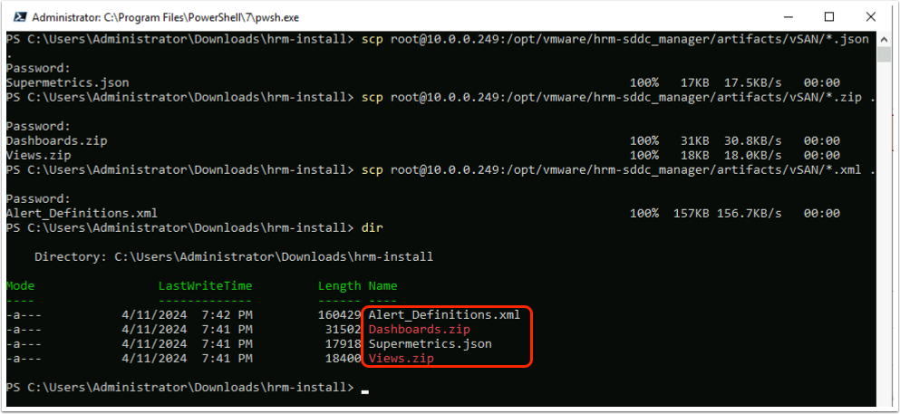

You should now have these 4 new files. You will importing them into Operations.

To import dashboards, views and super metrics, you perform this procedure in VMware Aria Operations with a user assigned the Administrator role.

## Import Views

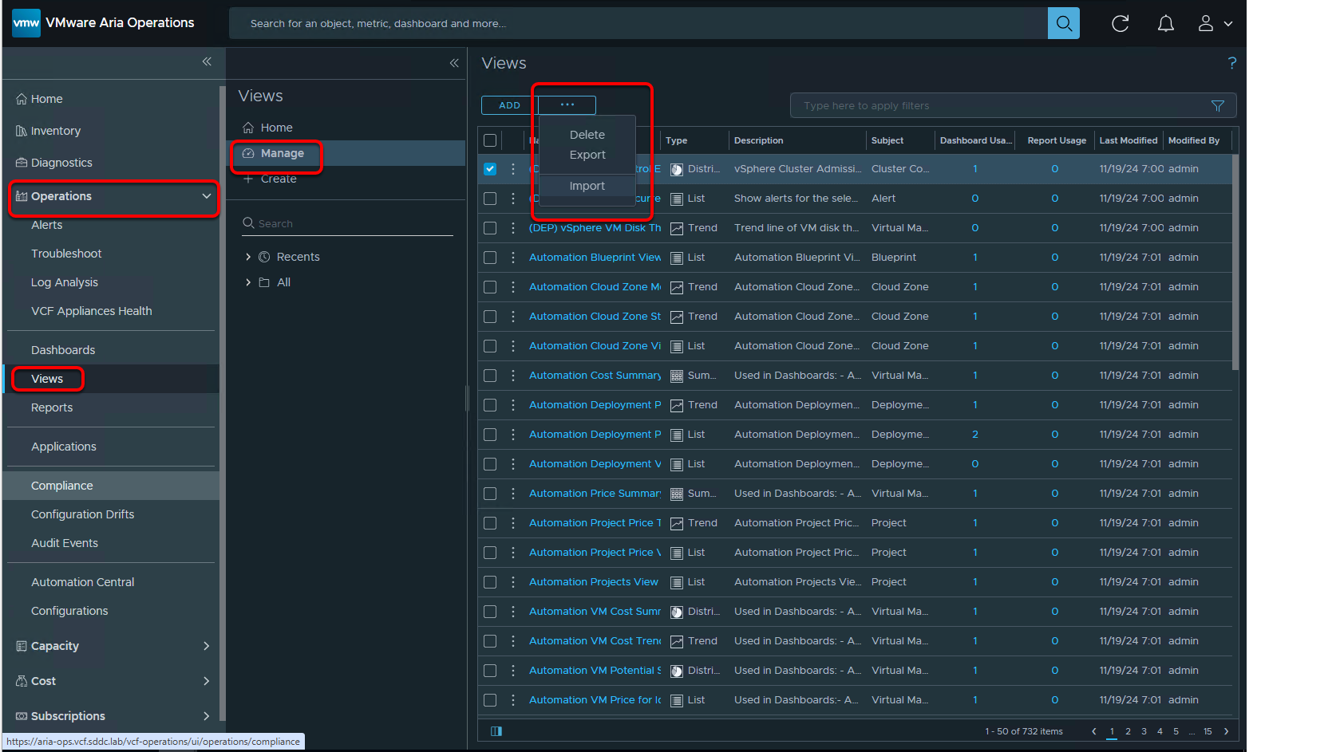

1. In the left pane, navigate to Operations --> Views --> Manage.
2. From the ellipsis or three dots drop-down menu, select Import.

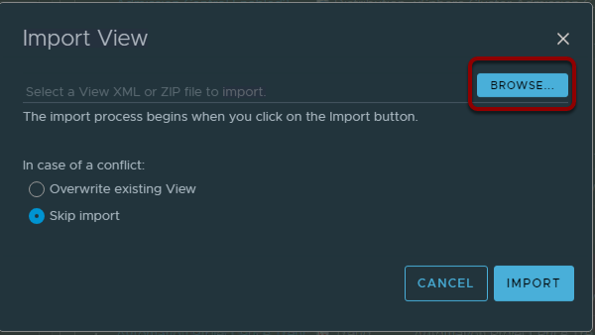

Click Browse

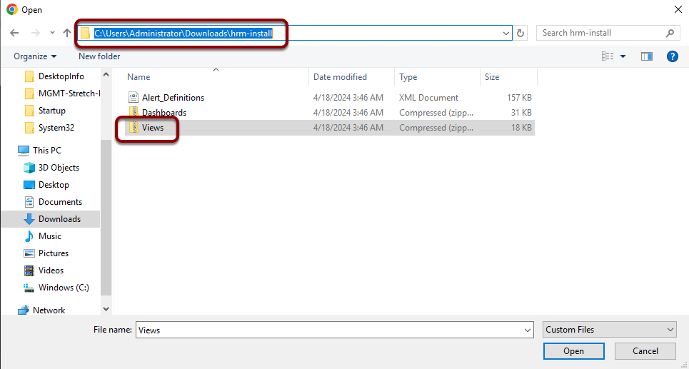

Change to where you downloaded the HRM Artifacts to earlier. i.e.

Click the Views.zip file and Open

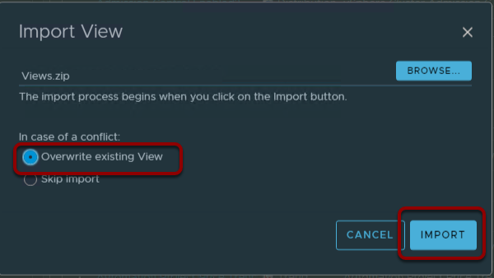

In this lab are some artifacts left from a previous lab, click the Overwrite existing View radio check button

Click IMPORT

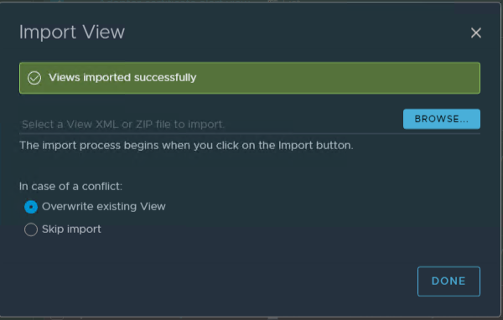

Click DONE

## Import Super Metrics

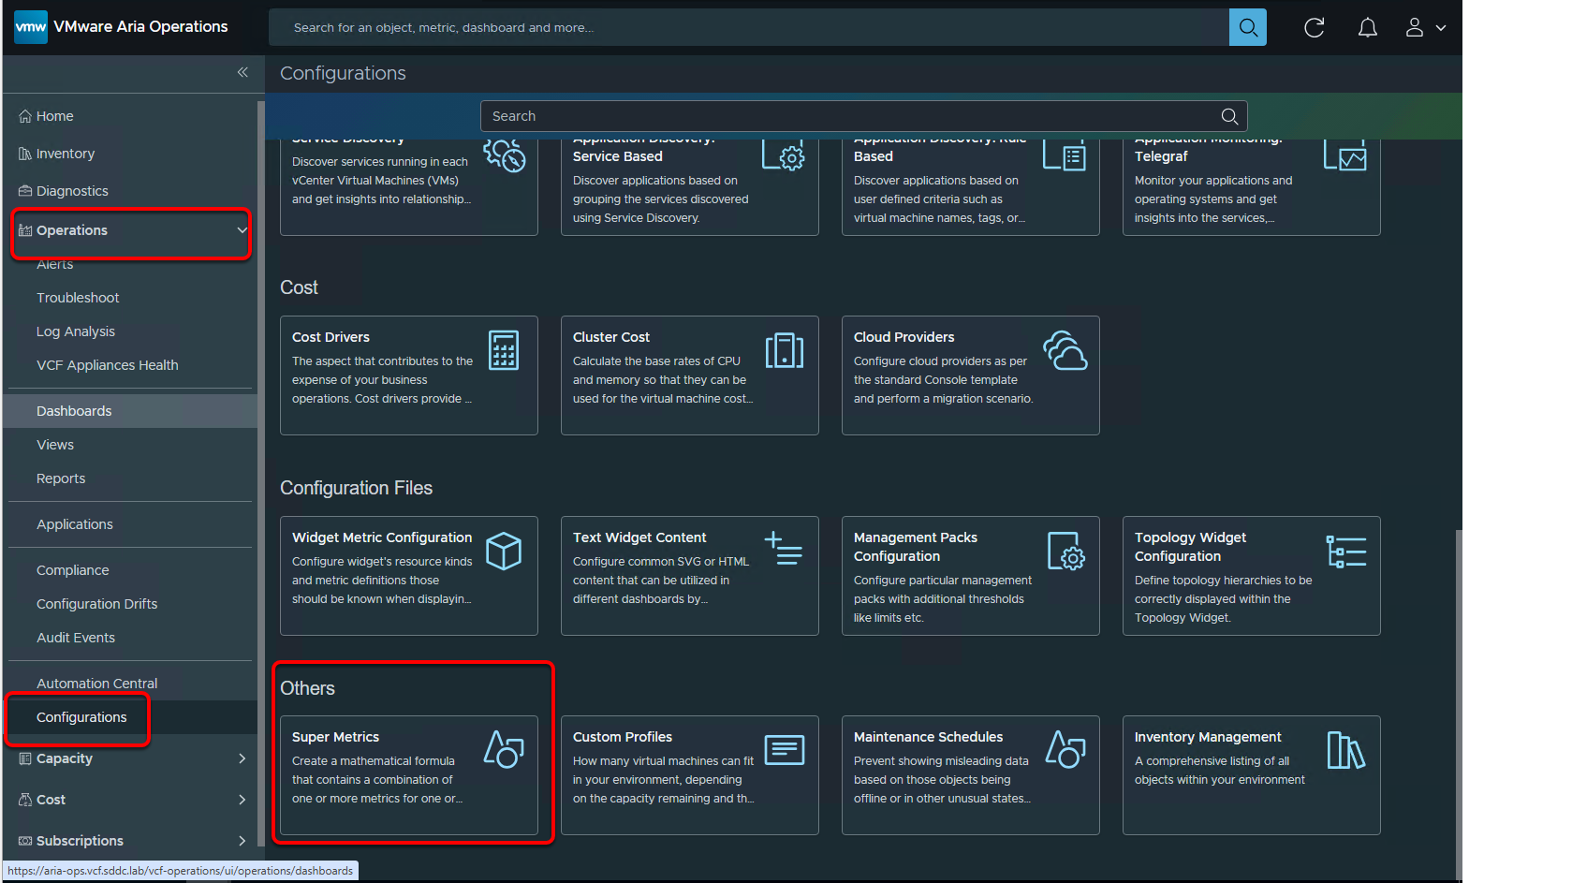

In the left pane, navigate to Operations --> Configurations --> Others -->Super metrics.

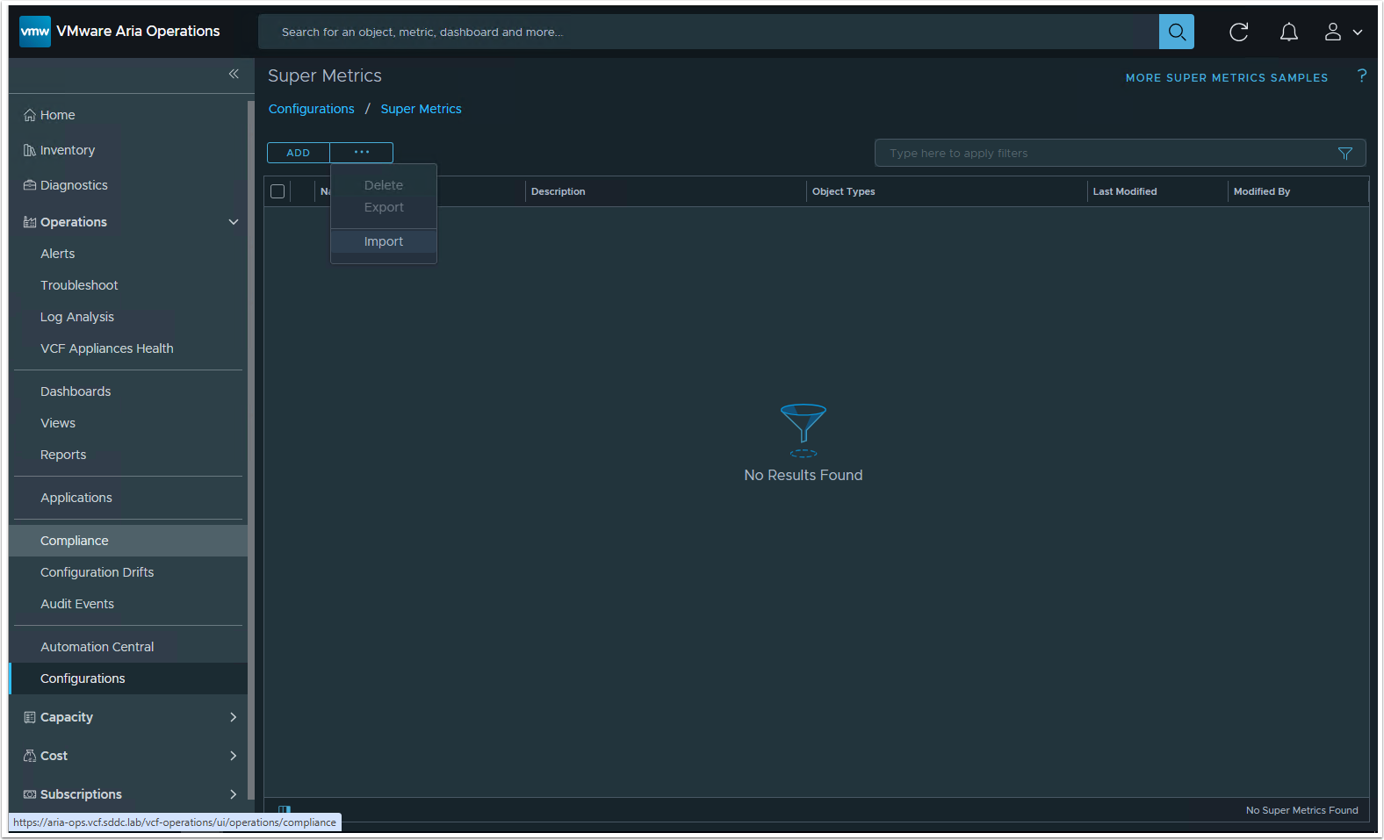

From the ellipsis drop-down menu, select Import.

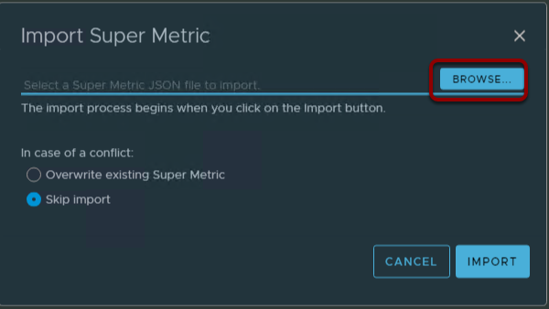

Click Browse

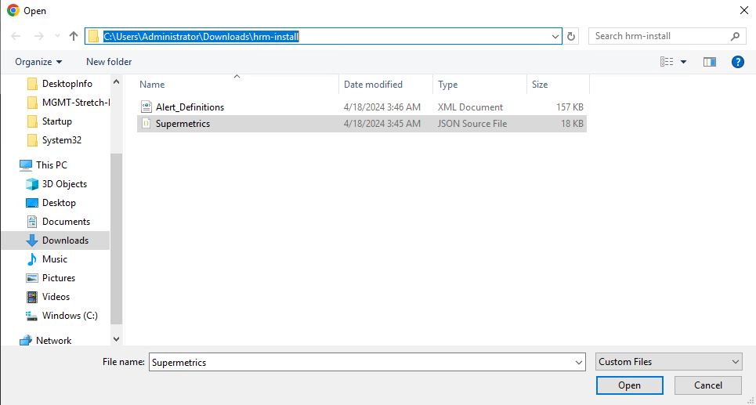

Change to where you downloaded the HRM Artifacts to earlier. i.e.

Click the Supermetrics.json file and Open

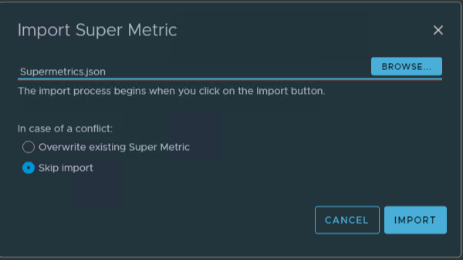

Click IMPORT

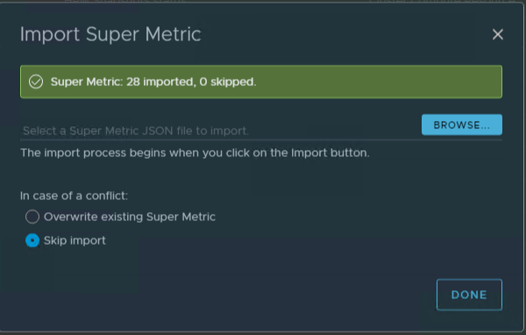

Click DONE

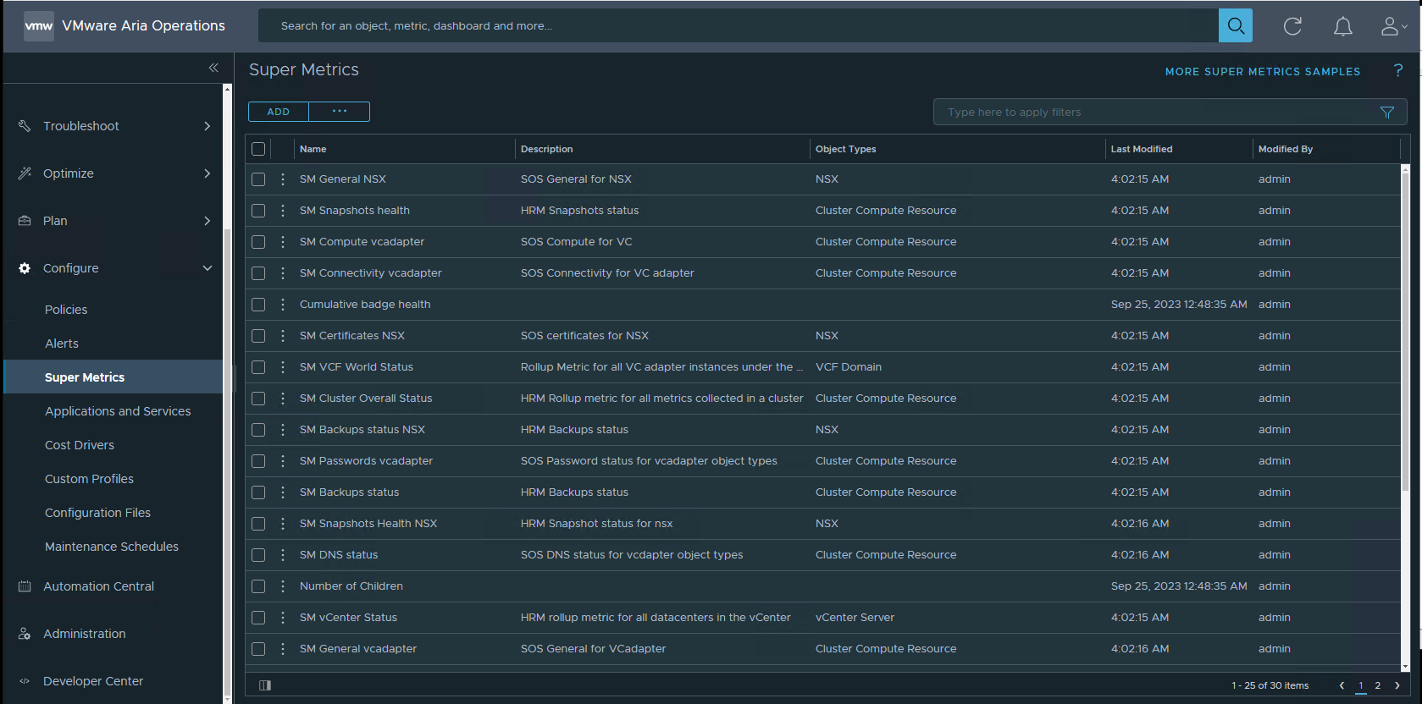

## Enable Super Metrics

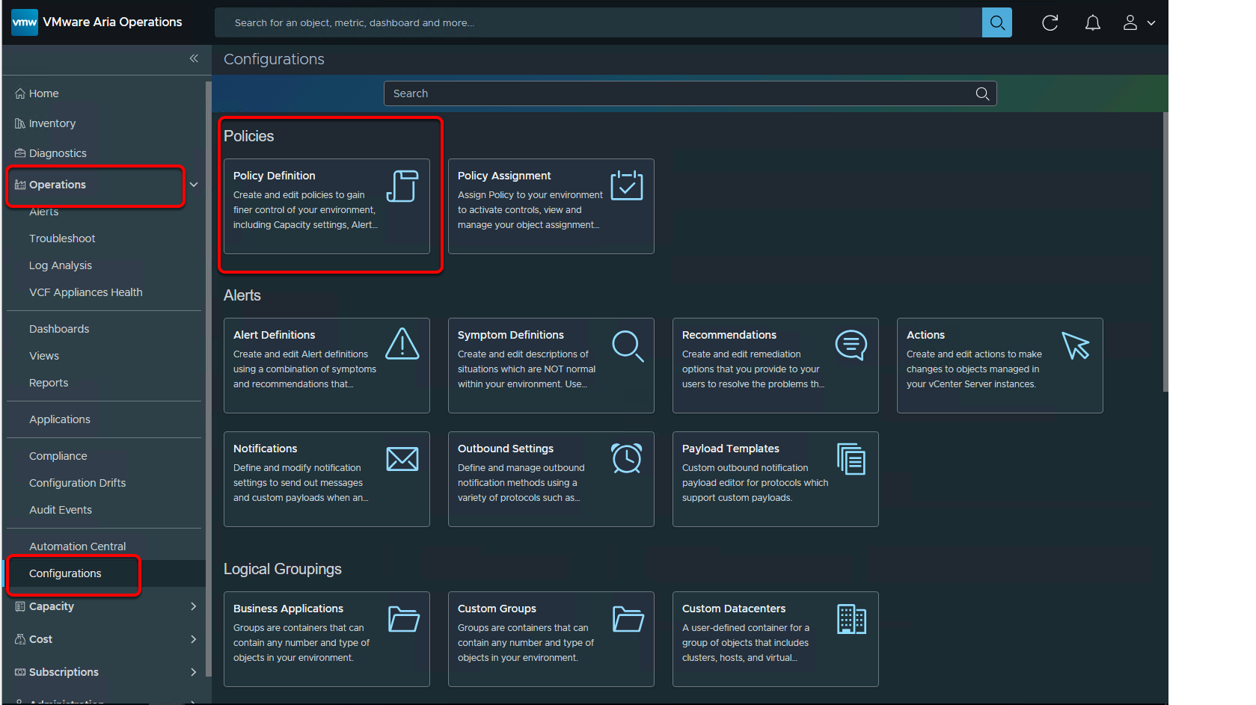

1. In the left pane, navigate to Operations --> Configurations --> Policies -->Policy Definition.

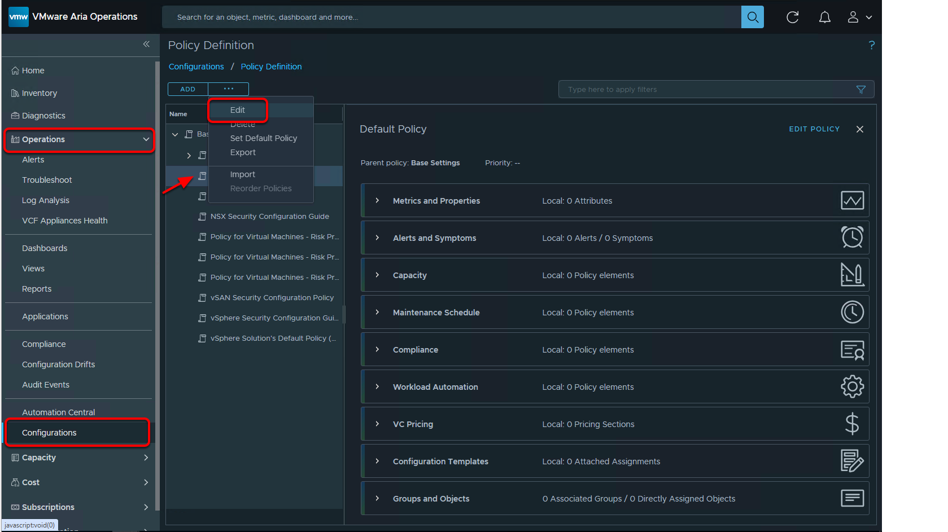

 select the Default policy and, from the ellipsis drop-down menu, select Edit.

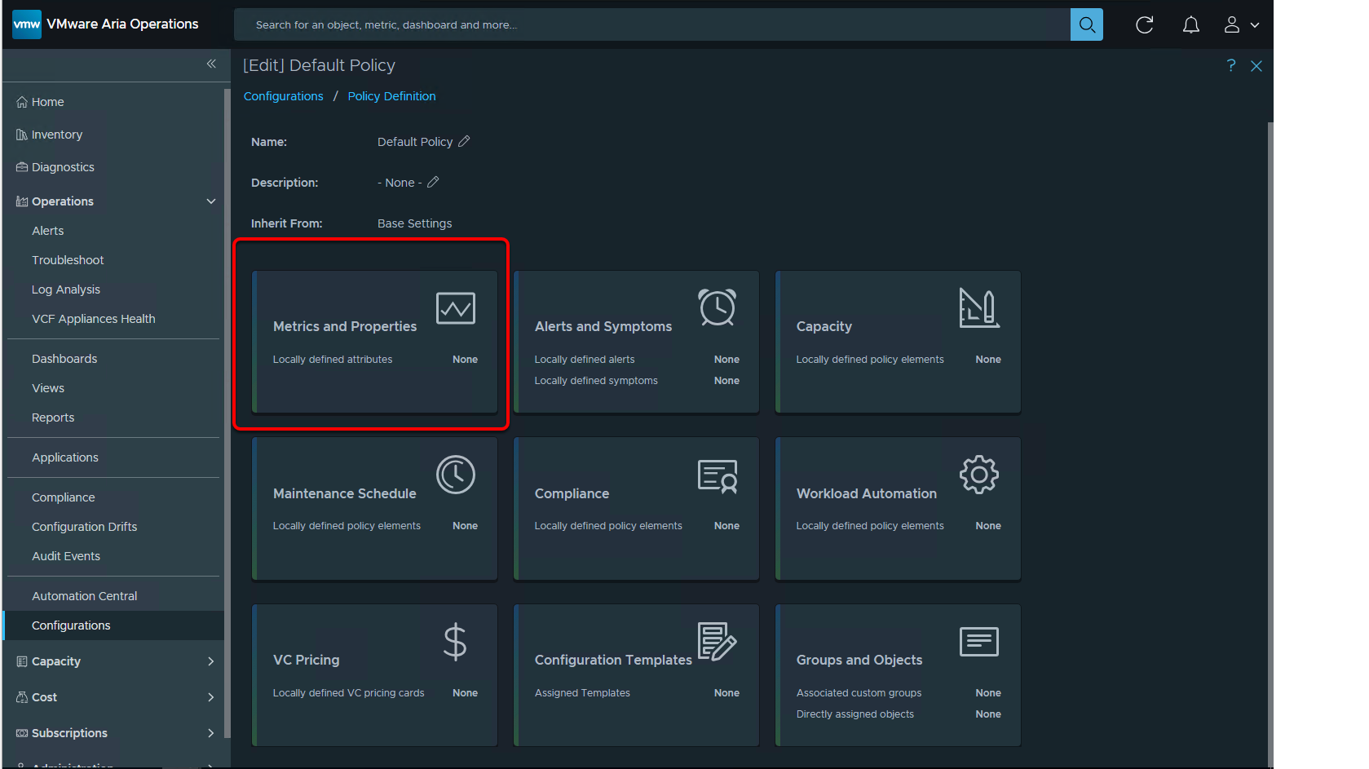

1. On the Default policy page, click the Metrics and properties card.

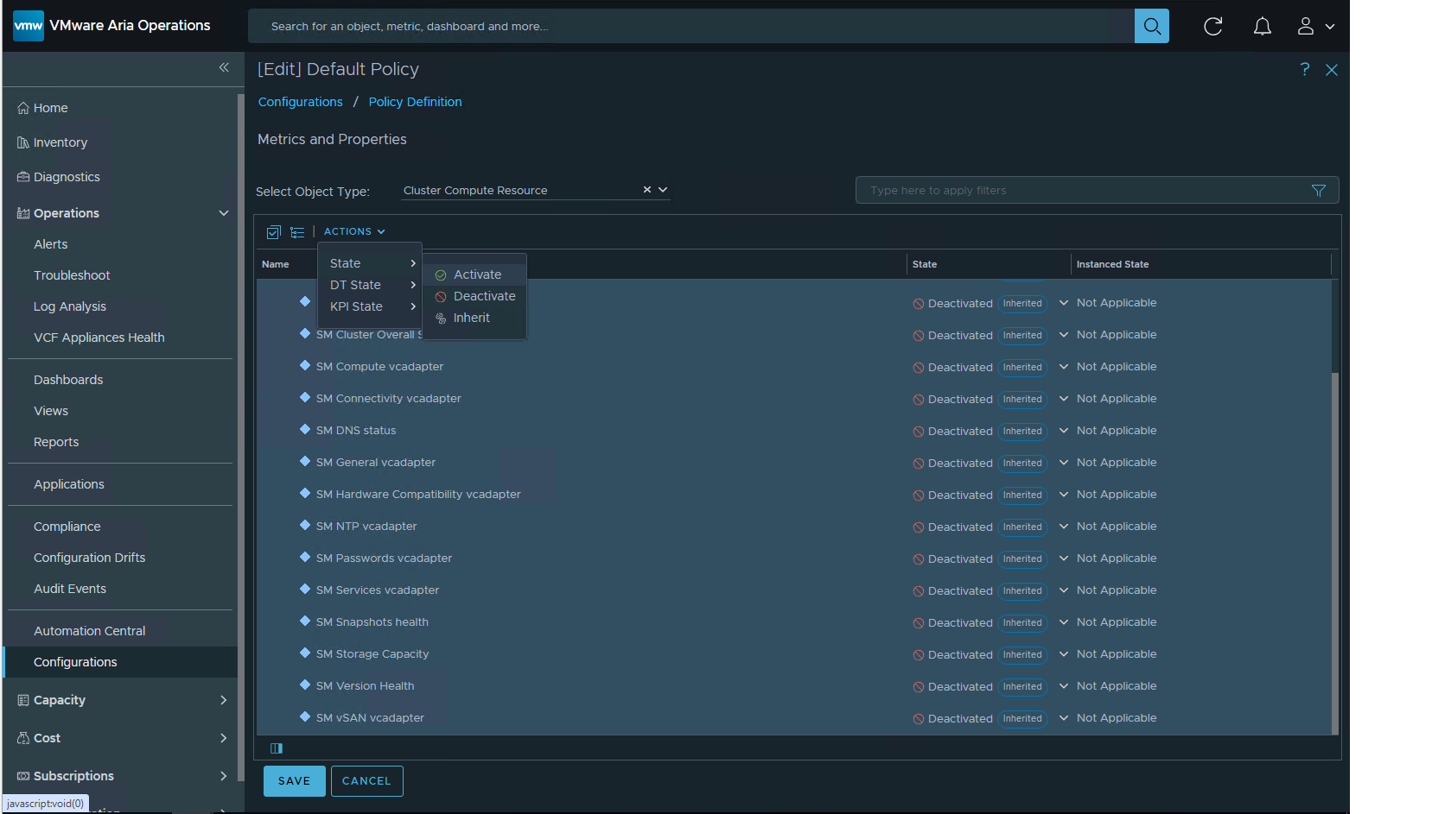

From the Select object type drop-down menu, select vCenter --> Cluster compute resource

Expand Super metrics and select all super metrics beginning with SM.

From the Actions drop-down menu, select State --> Activate.

click SAVE.

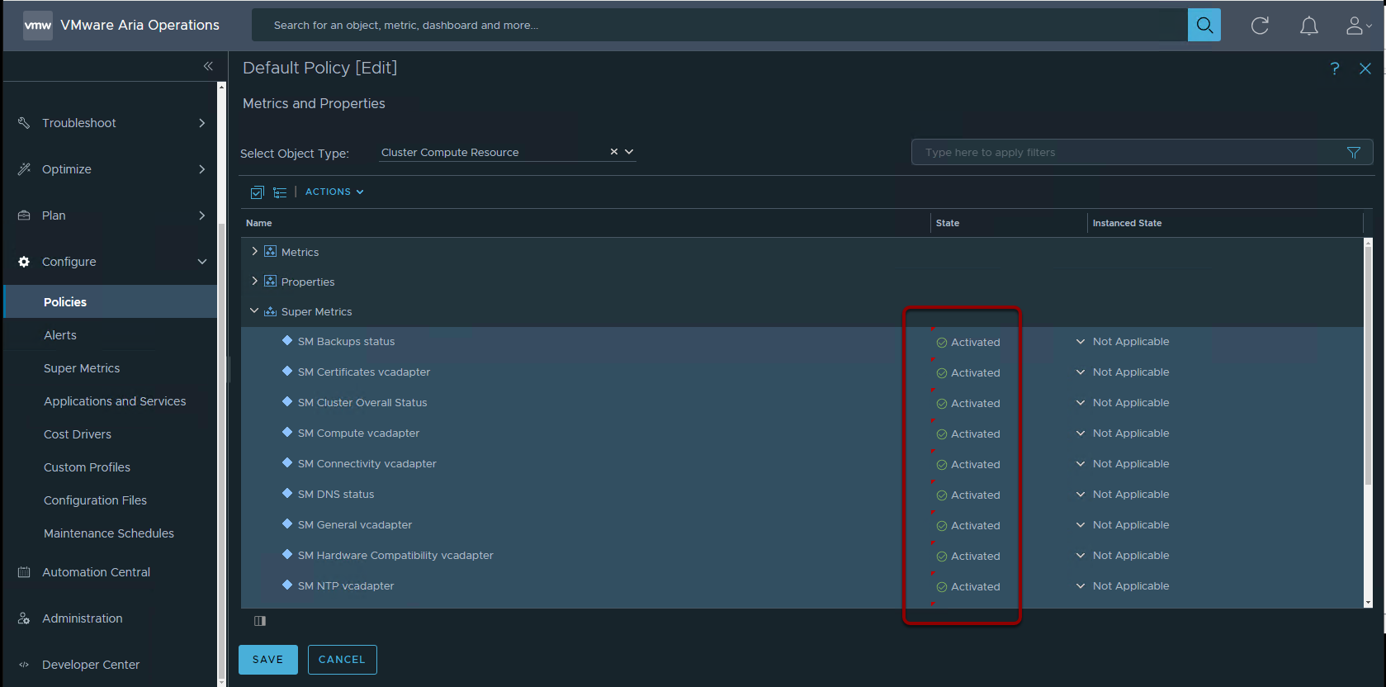

Repeat this step to activate the following:

## Import Dashboards

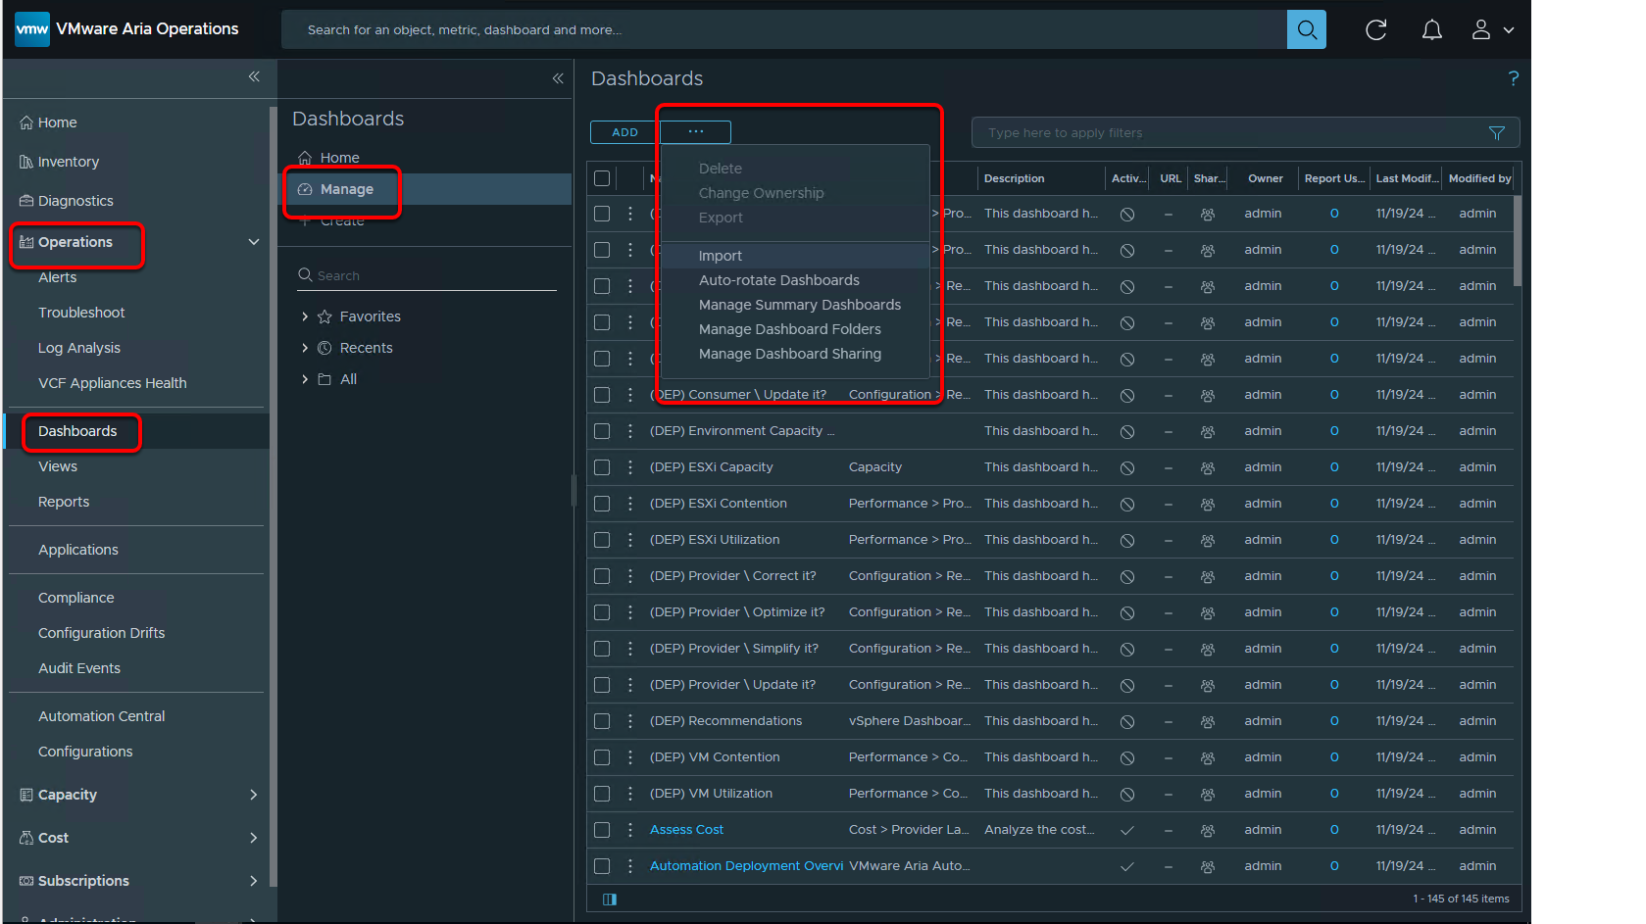

In the left pane, navigate to Operations --> Dashboards --> Manage

From the ellipsis drop-down menu, select Import.

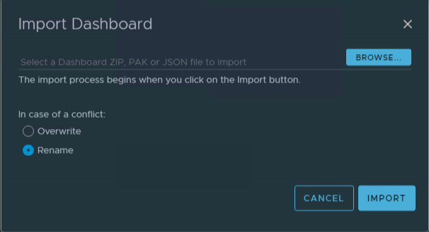

Click Browse

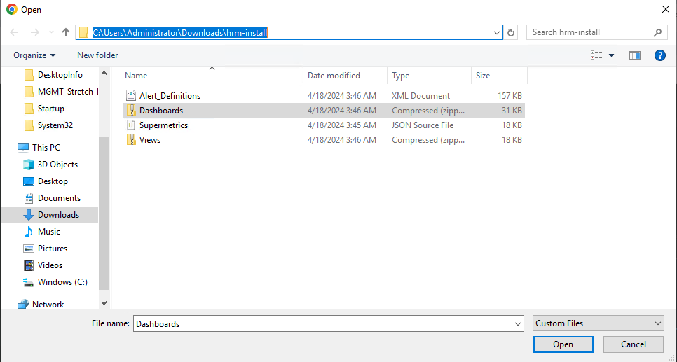

Change to where you downloaded the HRM Artifacts to earlier. i.e.

Click the Dashboards.zip file and Open

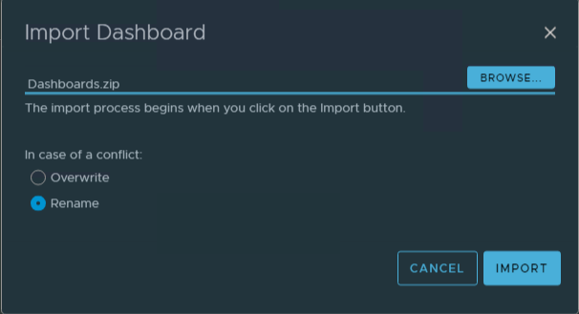

Click IMPORT

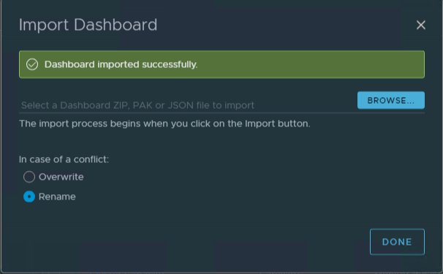

Click DONE

## Import and Configure Alerts in VMware Aria Operations for Health Reporting and Monitoring for VMware Cloud Foundation

To enable alerts in VMware Aria Operations, you import the Alert_Definitions.xml file provided with the Python Module for VMware Cloud Foundation Health Monitoring in VMware Aria Operations and enable the alerts. The alerts comprise of an alert definition, one or more symptom definition, and recommendations.

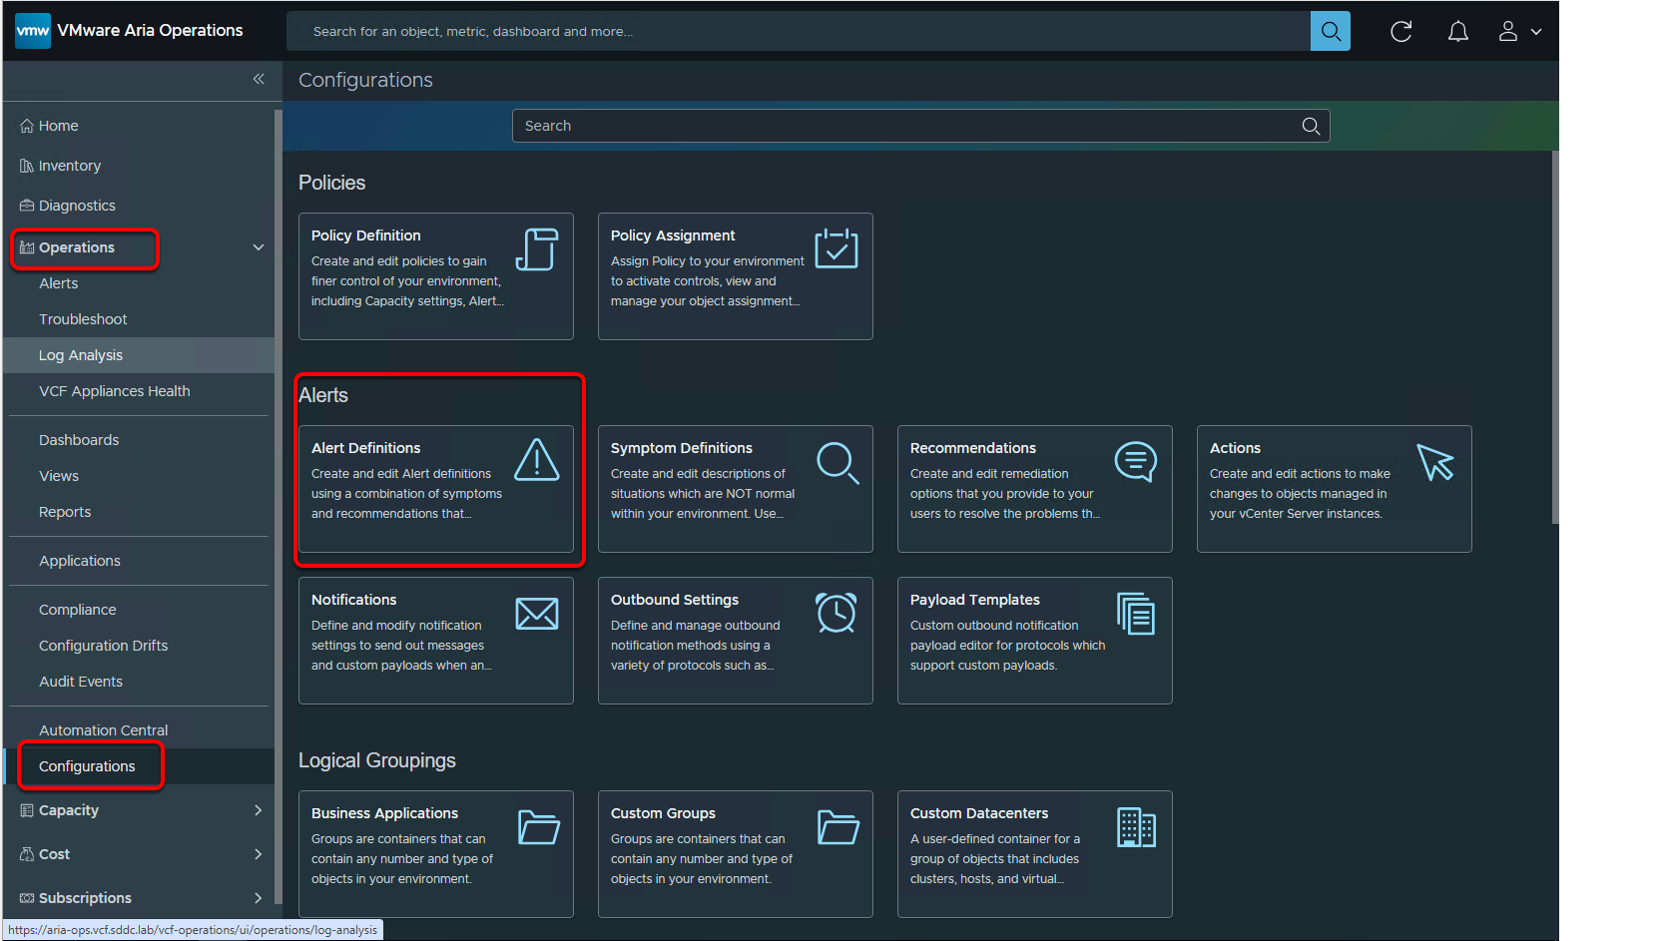

In the left pane, navigate to Operations Configurations --> Alerts --> Alert Definitions

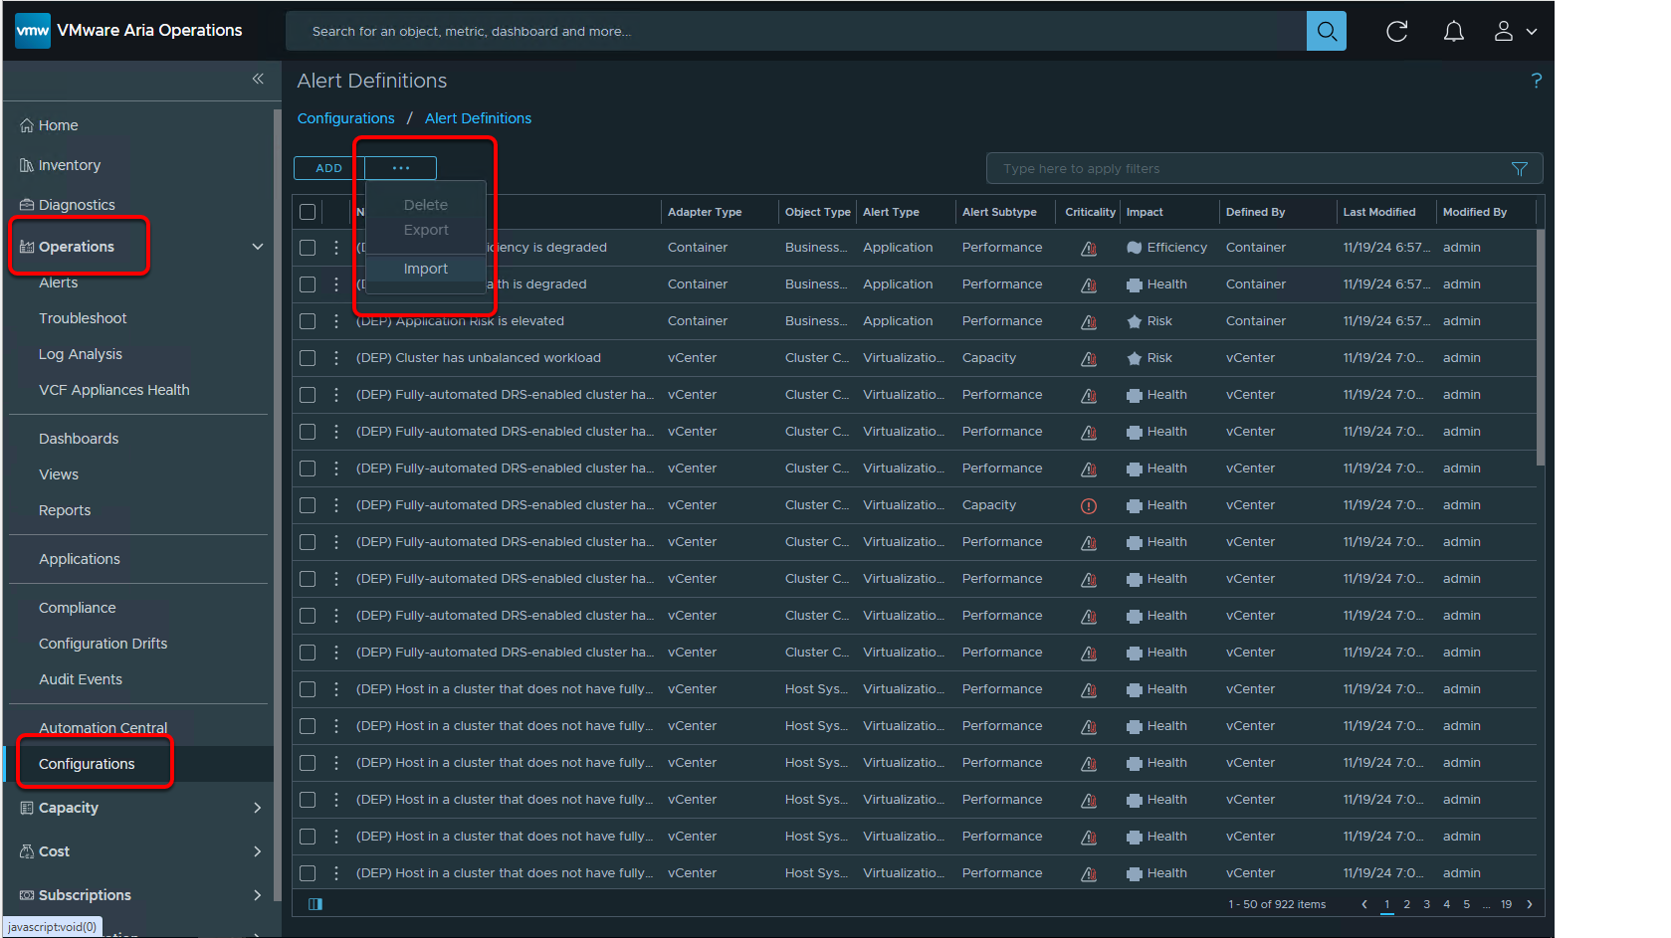

from the ellipsis drop-down menu, select Import

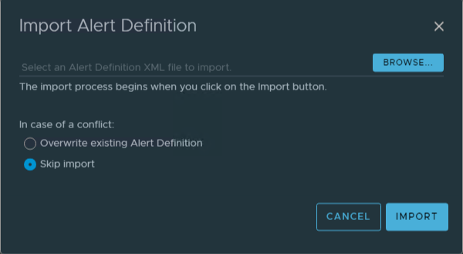

Click Browse

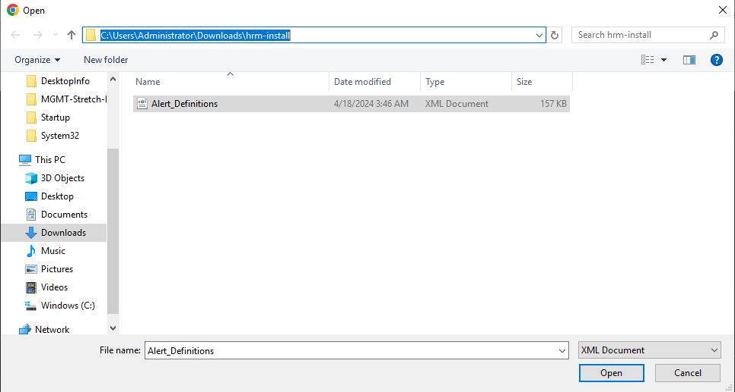

Change to where you downloaded the HRM Artifacts to earlier. i.e.

Click the Alert_Definitions.xml  file and Open

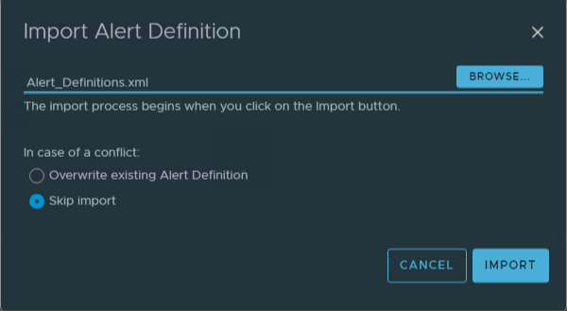

Click IMPORT

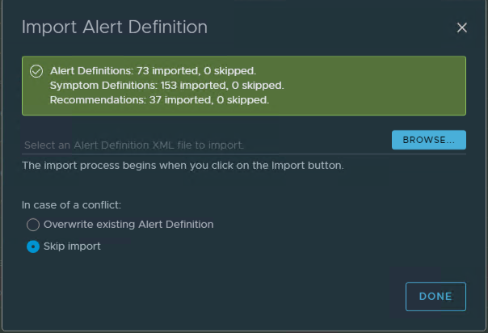

Click DONE

## Alert Policies

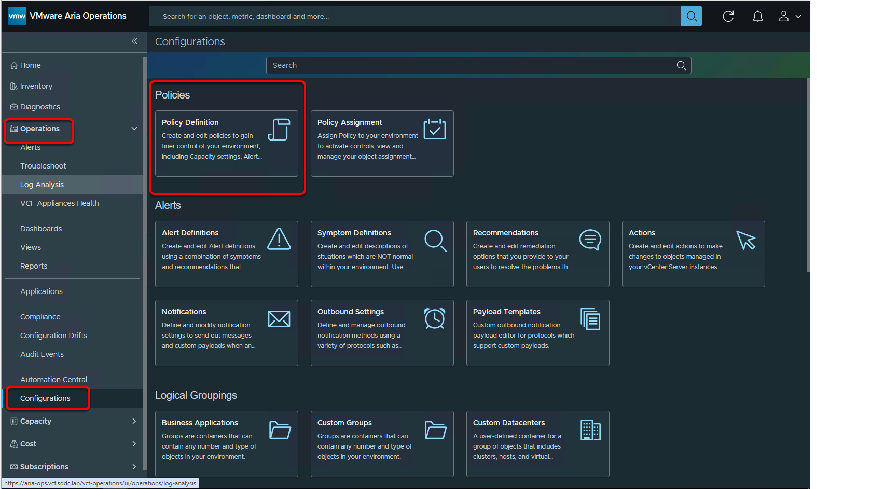

In the left pane, navigate to Operations --> Configurations --> Policies -->Policy Definition

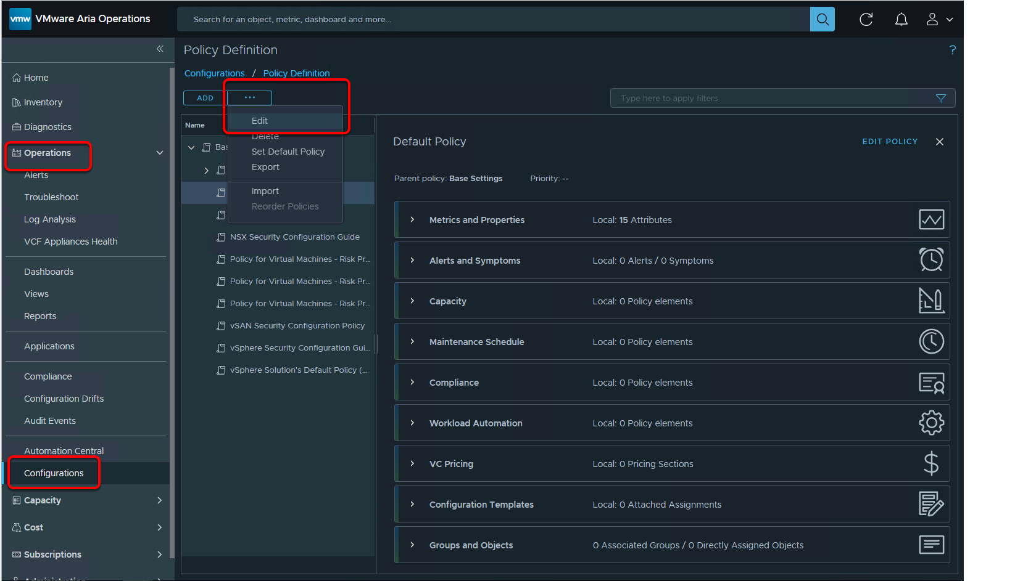

On the Policy Definition page, select the Default policy and, from the ellipsis drop-down menu, select Edit

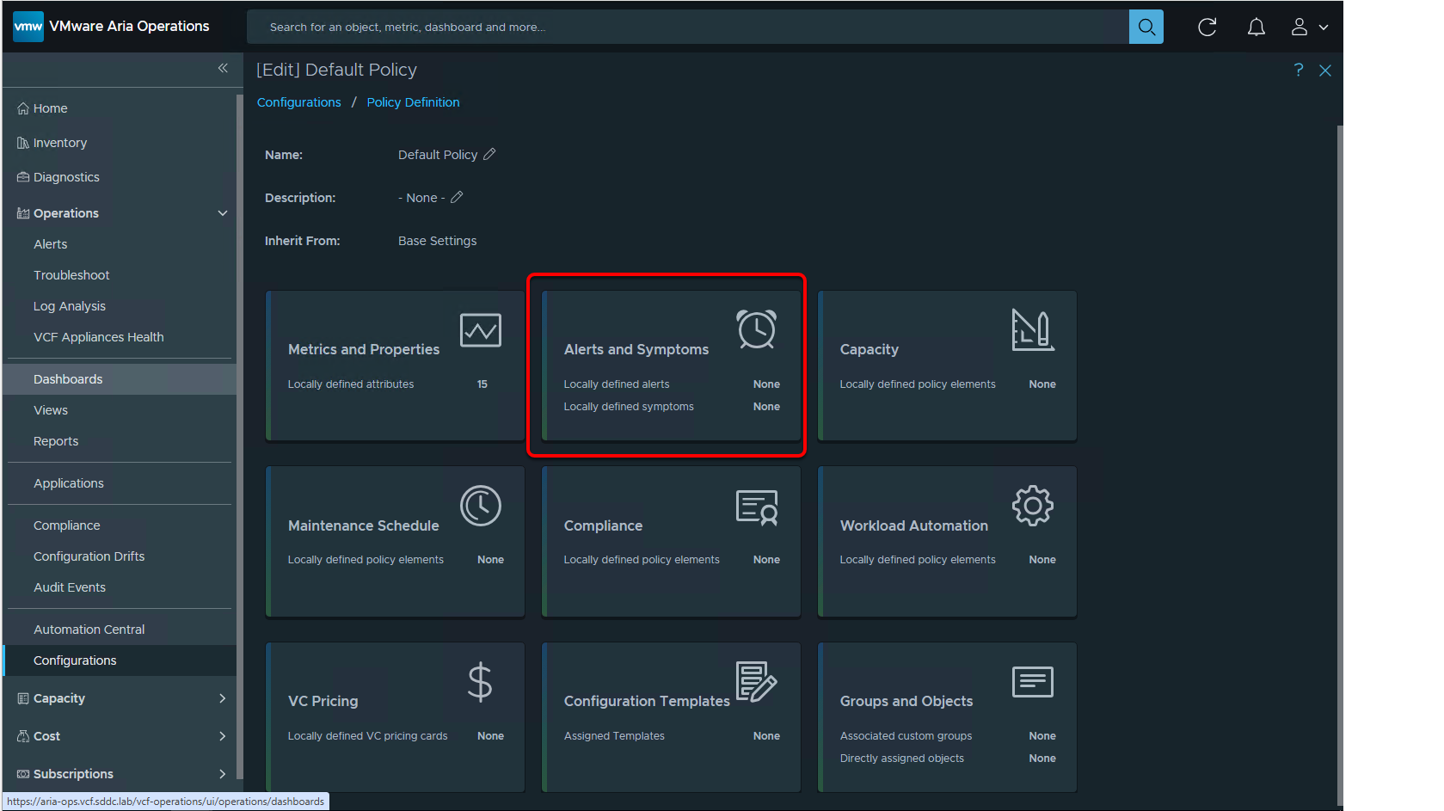

click the Alerts and symptoms card.

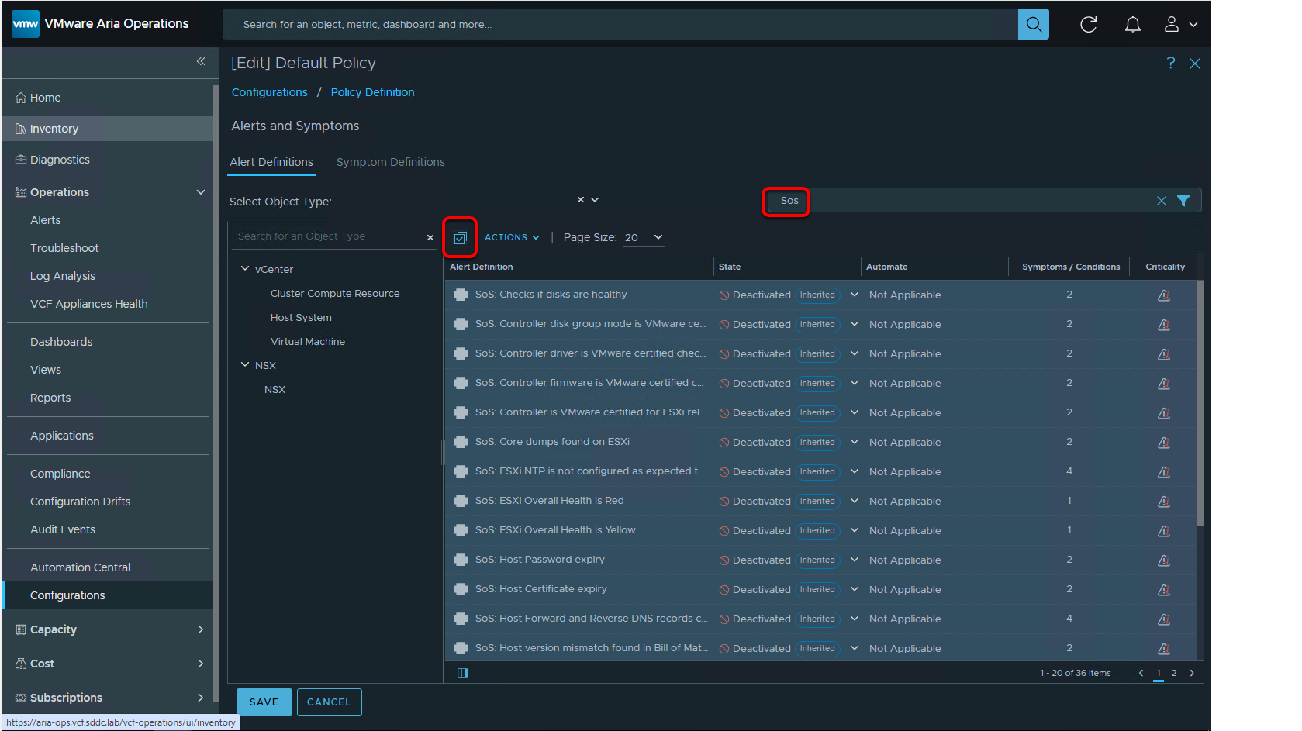

In the Filter text box, enter SoS

click the Select all icon.

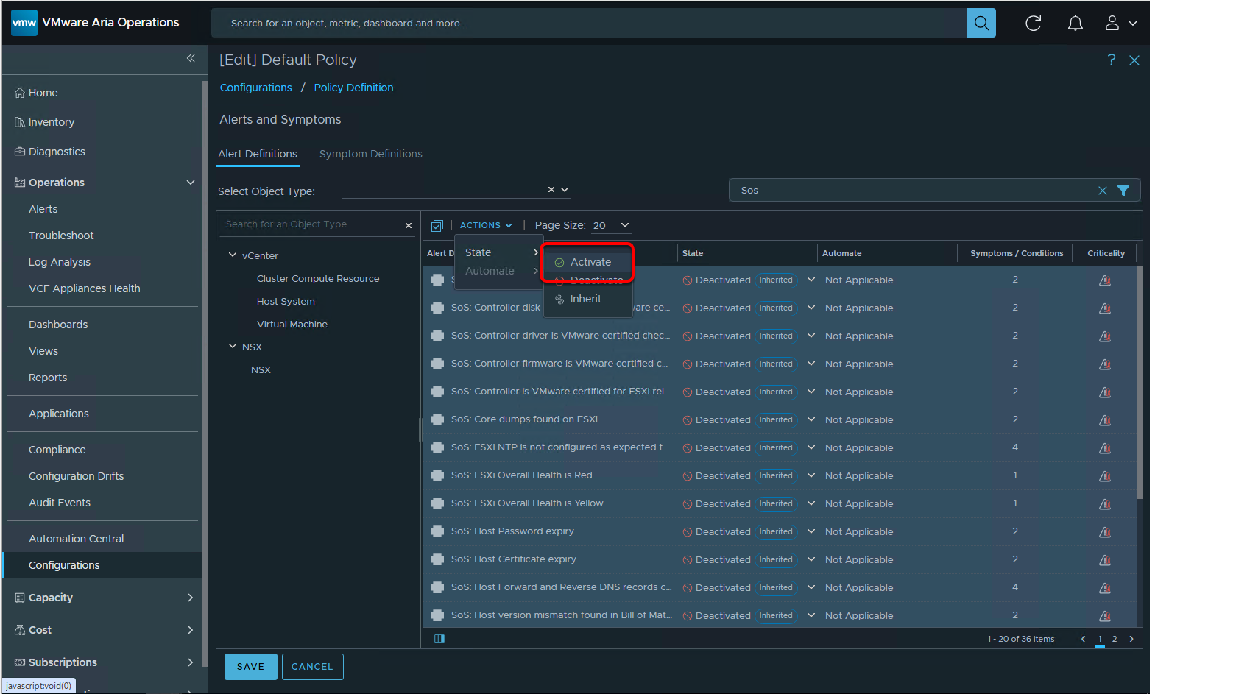

From the Actions drop-down menu, select State --> Activate

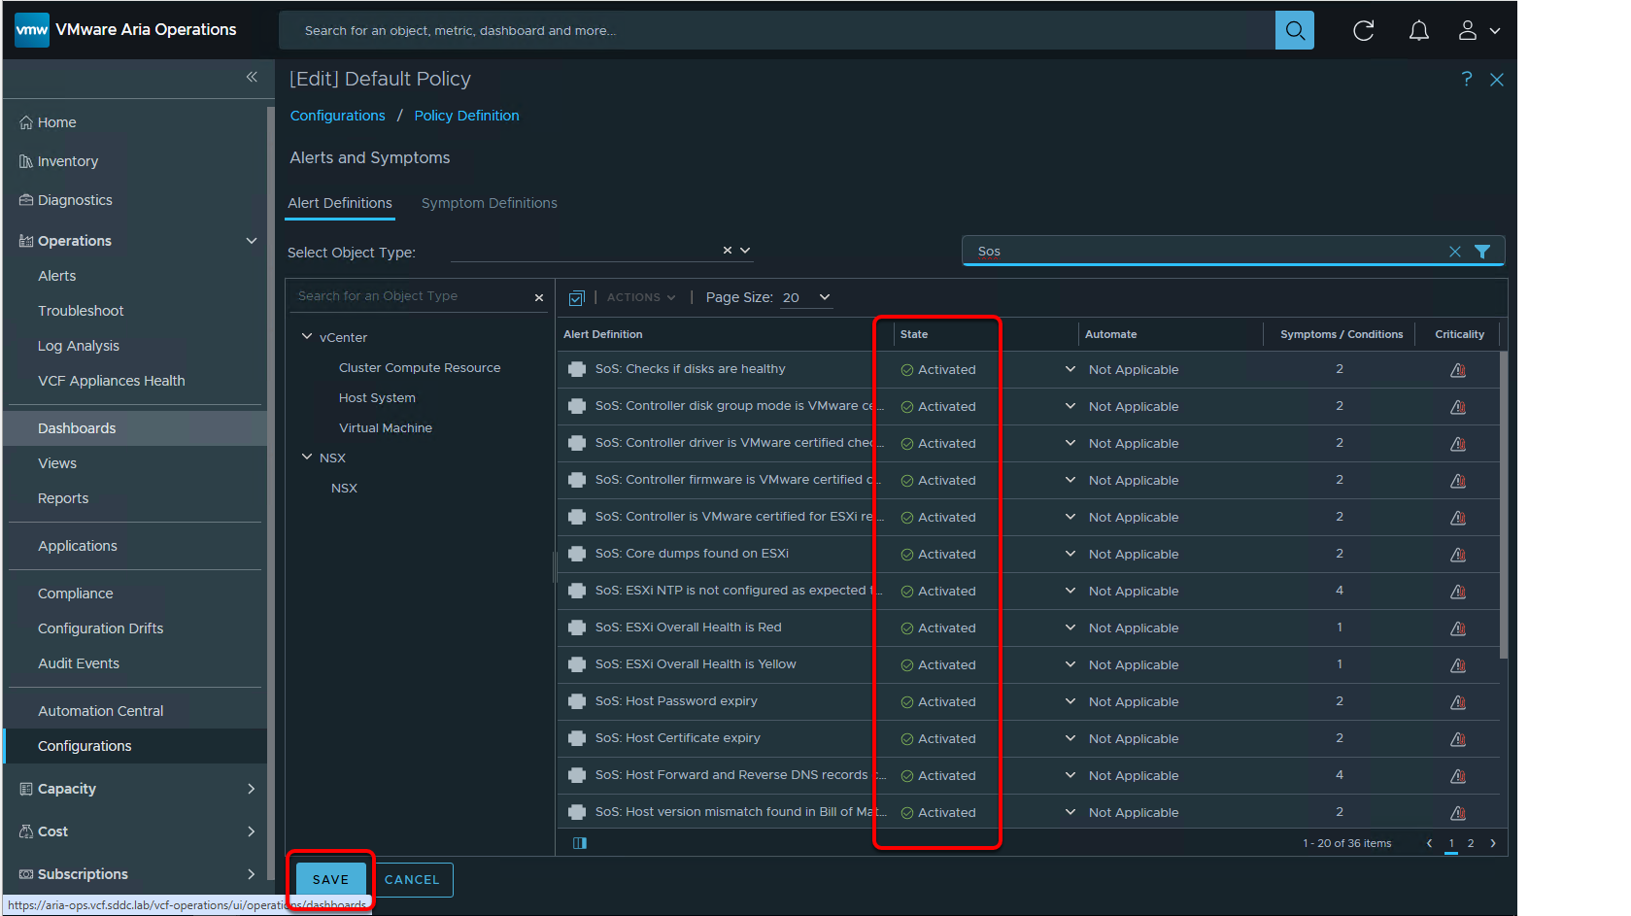

click SAVE

## Import and Configure Notifications in VMware Aria Operations for Health Reporting and Monitoring for VMware Cloud Foundation

At this point the Install of the Health Reporting and Monitoring for VMware Cloud Foundation Validate Solution is almost done. The last steps is to enable and configure Email or Slack notifications in Operations. The way the lab is setup does not currently support this. Just know that this is a capability and you can look at the last step in the doc at https://docs.vmware.com/en/VMware-Cloud-Foundation/services/vcf-health-reporting-and-monitoring-v1/GUID-4247C0E9-656F-4B7E-9801-820C6F435A88.html to see the steps needed for this part of the solution.

## Done

After the VVS has been implemented you help your customer with the Operationalization of Operations in their Eco System.  Help them identify and assign personas, verify with the teams that the solution is providing the data required, do gap analysis on the solution, and a host of other day 2 efforts. That is out of scope for this lab. However guidance on these and other focus areas can be found at https://docs.vmware.com/en/VMware-Cloud-Foundation/services/vcf-health-reporting-and-monitoring-v1/GUID-2E1DFDA5-2448-4207-80EF-20296794F427.html

This concludes the lab

## 7. Optional - Add Physical Location to Operations

In preparing for this lab and other Operations labs we noticed something about the default VMware Cloud Foundation Operations Dashboard. There is a map can be configured to show the Geographical location of VCF Environments.

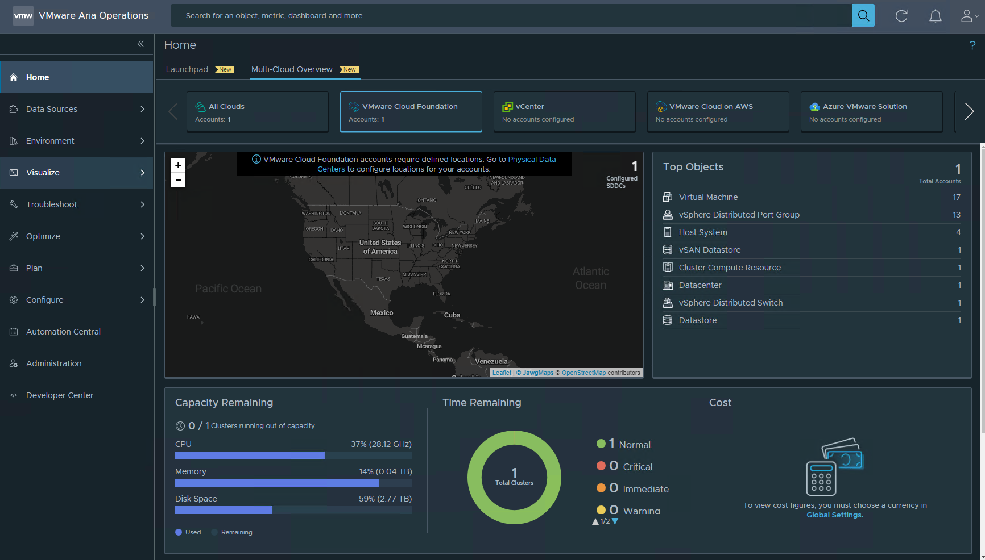

This is what it looks like without any customization. LiveFire thought you might appreciate a quick walkthough on how to configure Operations to show more specific, and hopefully accurate information on this map.

## Add Physical Data Center Information to Operations

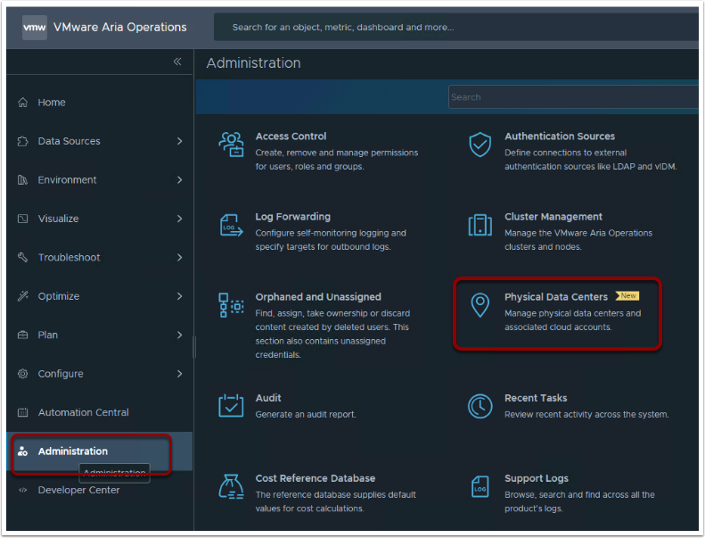

Click on Administration

Click on Physical Data Centers

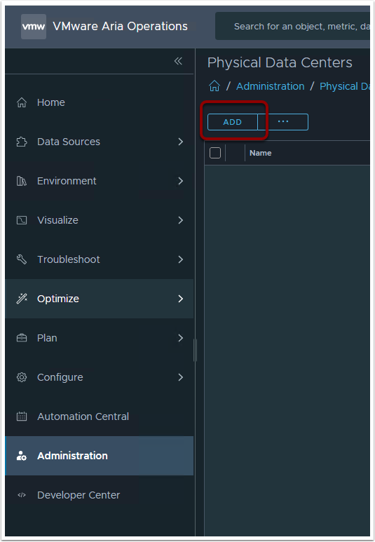

Click ADD

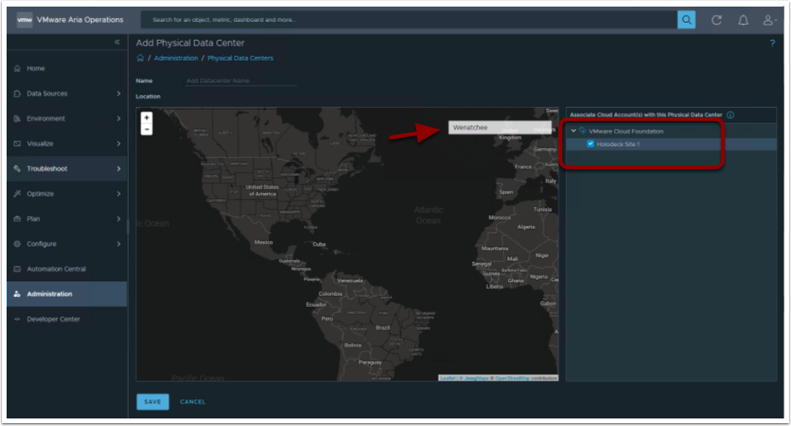

On the Right Expand the list and select the VCF Environment

In the Search Window on the map Enter a location. Here we entered Wenatchee, which is where the Livefire Labs reside

Hit Enter in this map search Window

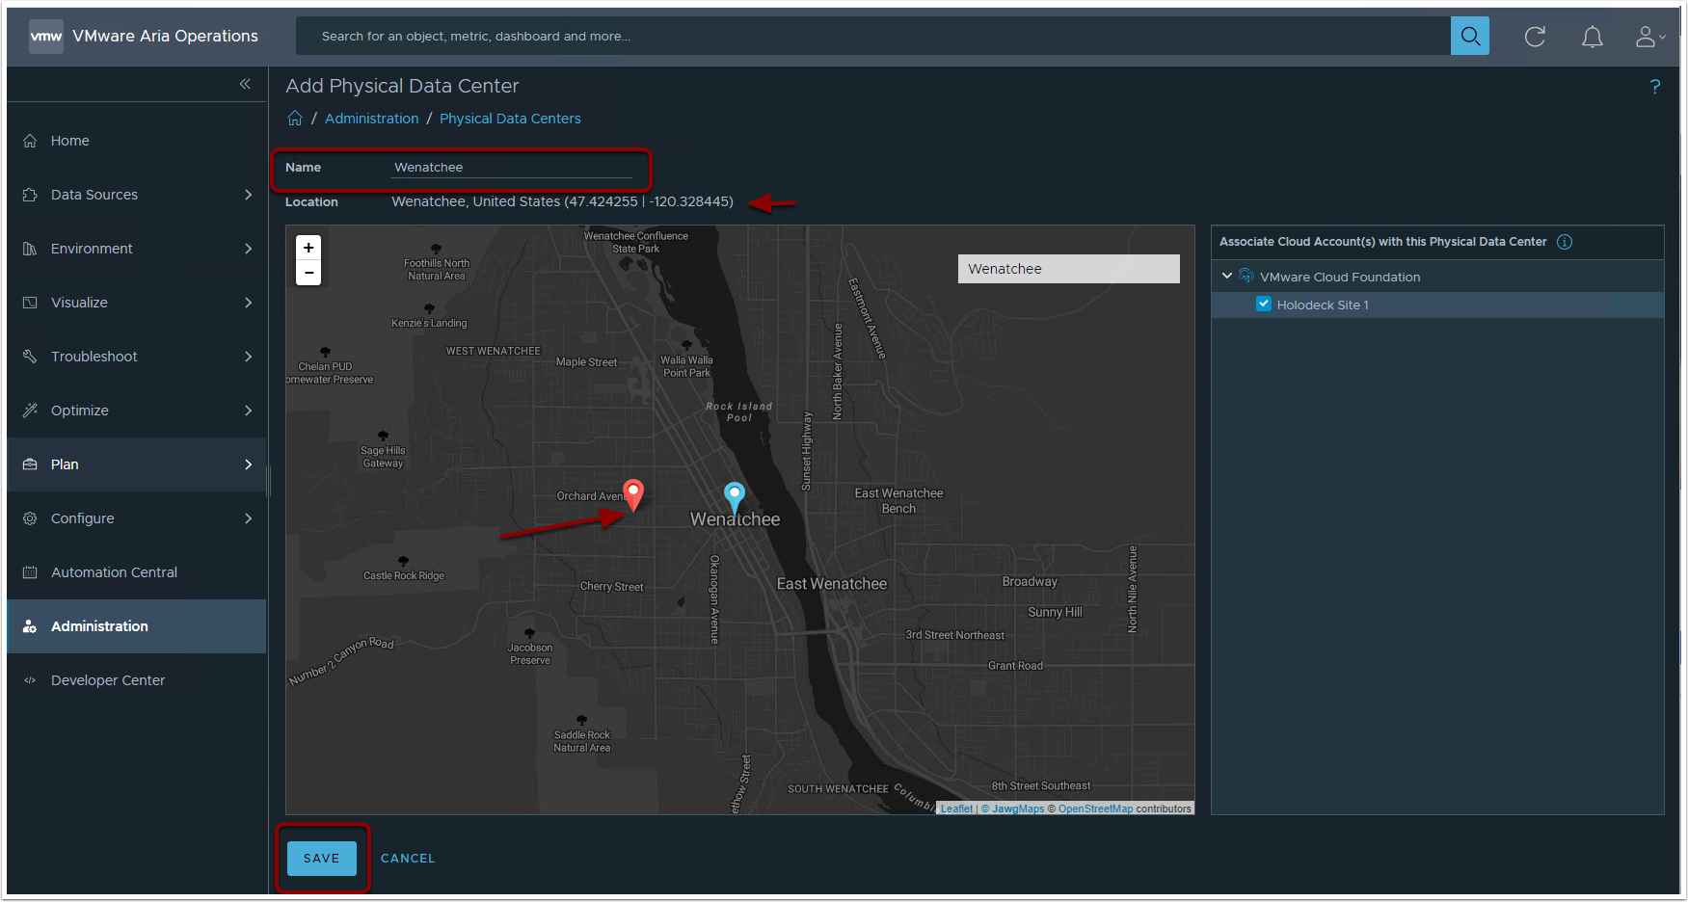

Zoom In until you can see the exact location of the Data Center

Enter a Name for Data Center

Double Click the location of the Data Center On the Map

Click Save

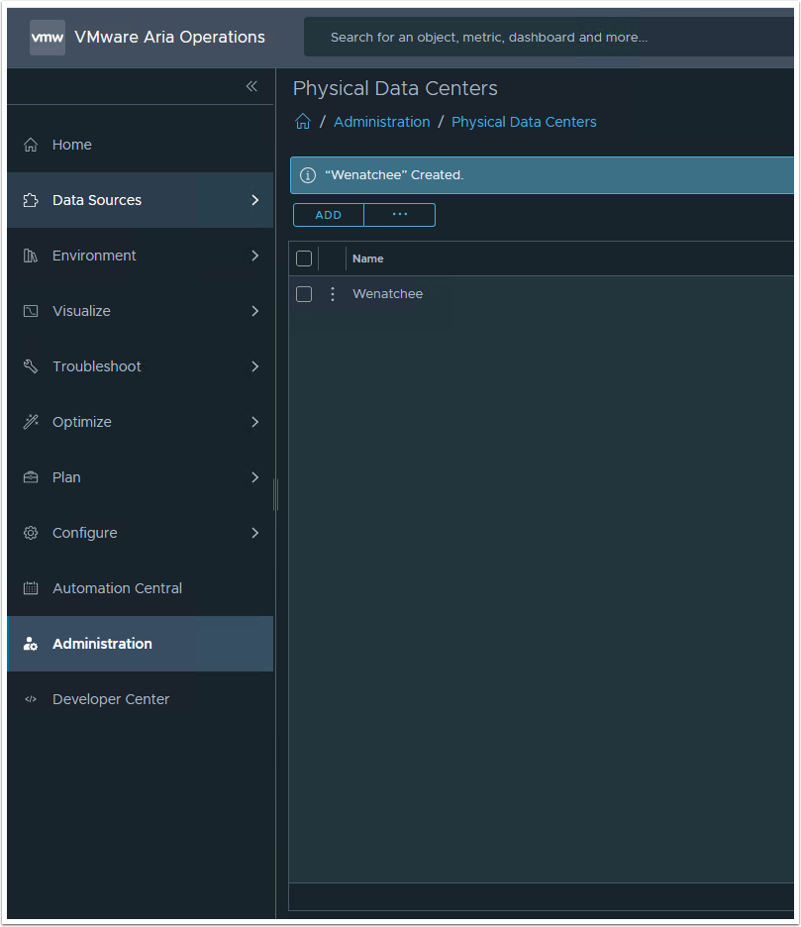

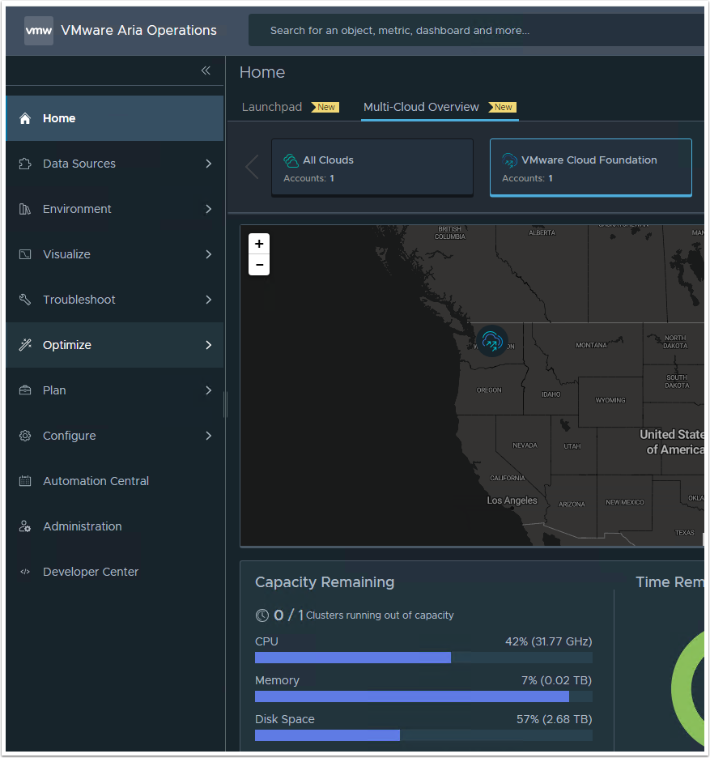

Go back to Home --> VMware Cloud Foundation --> Operation Overview

The Data Center should now show on the map

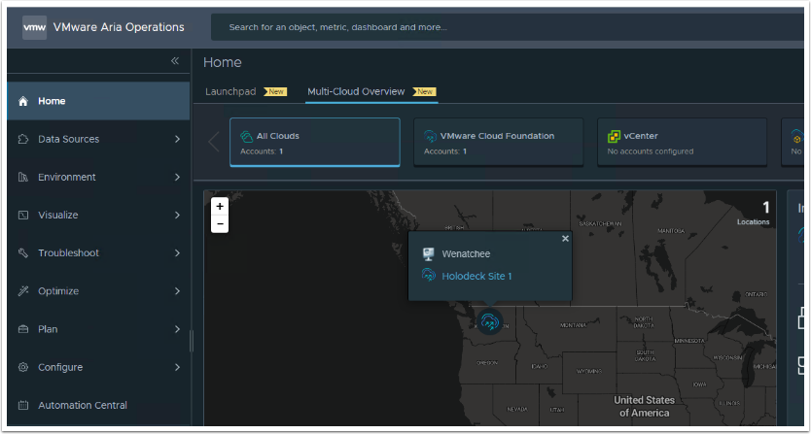

The Icon that shows the Data Center location has context links in it and can be used to drill down into detailed information.

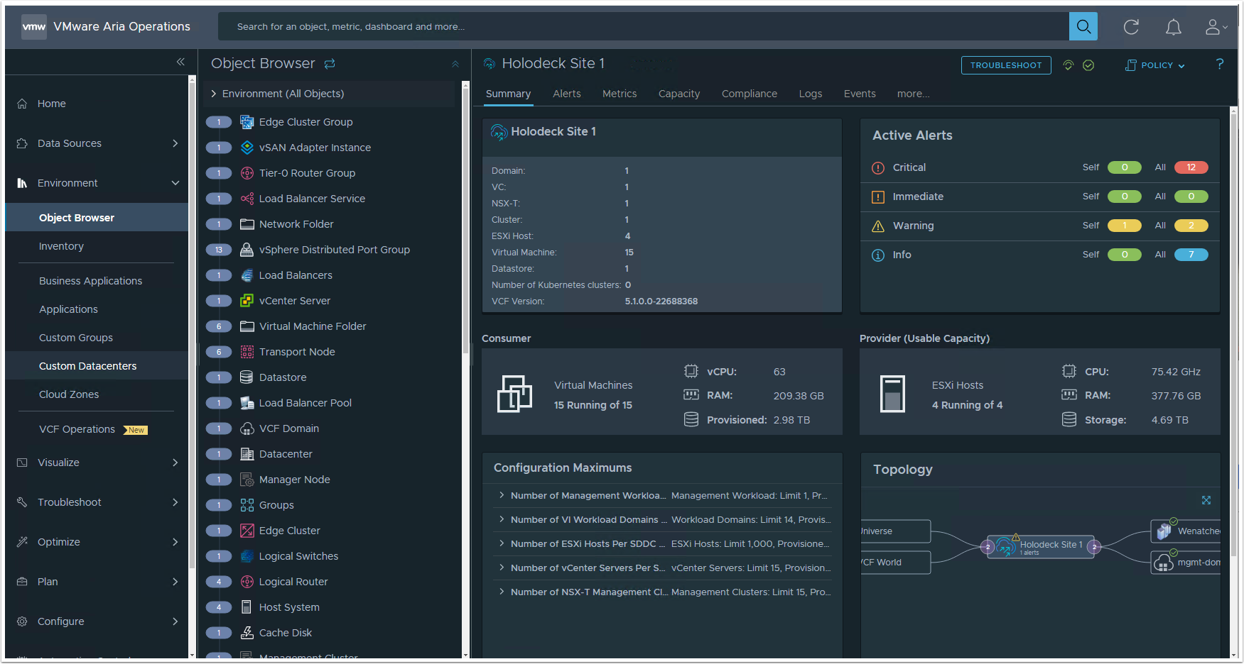

## Done

Thanks for the time you spent in this lab. We know your time is valuable, we hope you got some good information.

## Unlocking Aria Automation's Customization Power

* Lab 1 Intro - Assembler Extensibility
* Cloud Services Access
* 2. Creating a Custom Day 2 Resource Action Using Orchestrator
* Lab 2 Intro - Using REST API Calls in Orchestrator
* 1. Creating a vROPS Configuration Using REST APIs in Orchestrator
* 3. Testing the vROPS Webhook Alert Notification
* 4. Creating a vRSLCM Configuration Using REST APIs in Orchestrator
* 5. Testing vRSLCM Content Management
* 2. Creating a vROPS Webhook Alert Notification
* 1. Creating an Extensibility Subscription with Orchestrator

## Lab 1 Intro - Assembler Extensibility

## Cloud Services Access

## 1. Creating an Extensibility Subscription with Orchestrator

## PREREQUISITES

## 2. Creating a Custom Day 2 Resource Action Using Orchestrator

## Lab 2 Intro - Using REST API Calls in Orchestrator

## 1. Creating a vROPS Configuration Using REST APIs in Orchestrator

## PREREQUISITES

## Enable Basic Auth in vROPS

We will need to enable basic auth in vROPS to allow our api user account to run API rest calls.

1. Log into the vRealize Operations Primary node as root via SSH using your Putty session:

User: root

Password: VMware123!

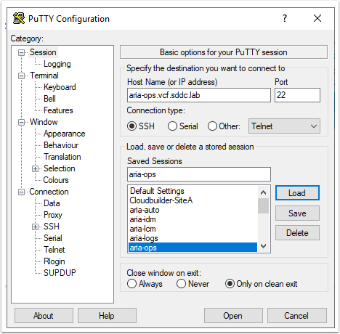

1. Open /usr/lib/vmware-vcops/user/conf/api-conf.properties in a text editor ysing the following:

vi /usr/lib/vmware-vcops/user/conf/api-conf.properties

1. Change the basicAuthentication.enabled property value to true by enterimg the following:

/basic  (to find the word basic in the file)

Shift A (to add to the end of the line)

Esc (to escape edit mode)

press x 5 times (to delete the false seting)

press a (for edit mode)

type in true

Esc (to escape edit mode)

Example: basicAuthentication.enabled=true

1. Save and close the file using the following:

Shift : (simultaneously)

and then wq!

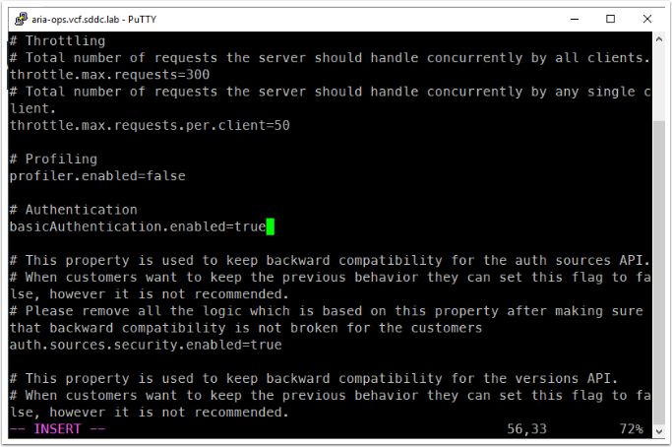

1. Restart the REST API service:

service api restart

Type exit to exit the putty session

## 2. Creating a vROPS Webhook Alert Notification

## PREREQUISITES

## 3. Testing the vROPS Webhook Alert Notification

## Testing, Testing

While logged into vROPS, enter your VM name in the search bar (this will be one of your VM's deployed in the previous labs)

1. Note the power status of the server, its should show as Powered On

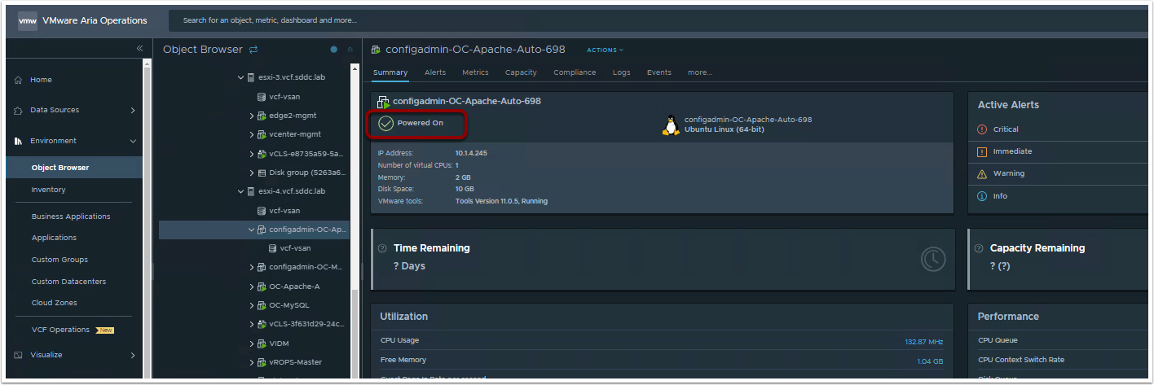

Log into the vSphere vCenter https://vcenter-mgmt.vcf.sddc.lab and locate your machine

(login to vSphere using administrator@vsphere.local / VMware123!)

1. View the Summary tab of the Virtual machine

2. Click on Actions and Select Power Off and Click on YES to confirm

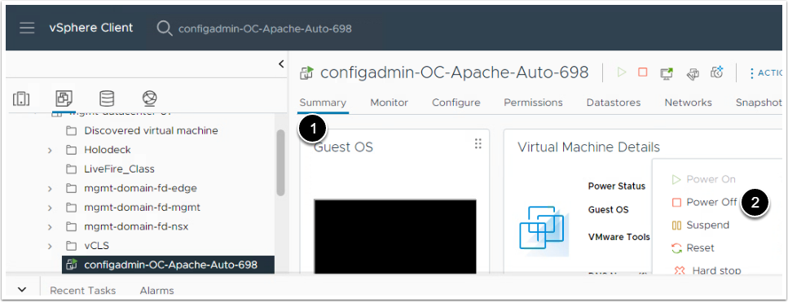

1. Confirm that the VM is powered off by viewing the Power Status in vSphere vCenter (either in the summary or under Recent Tasks).

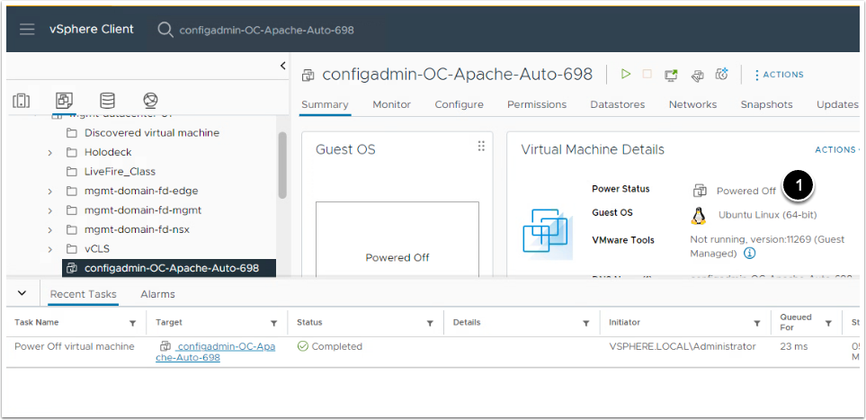

Welcome Back! Now let's take a look at the power status of your VM in vSphere.  If all worked as designed, your VM should now be powered back on.

Now let's take a look at what the webhook did by viewing the run in Orchestrator under Activity > Workflow Runs. We can see that the "Livefire Class Start a virtual machine and wait" workflow ran successfully.

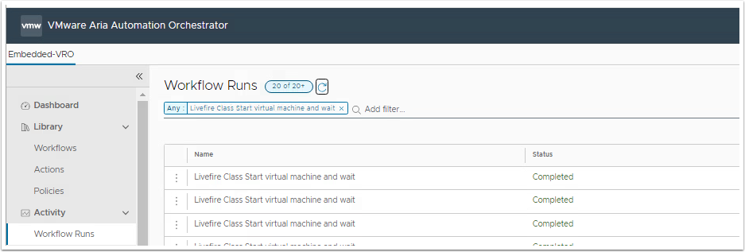

We can also open the workflow run to view more details in the logs.

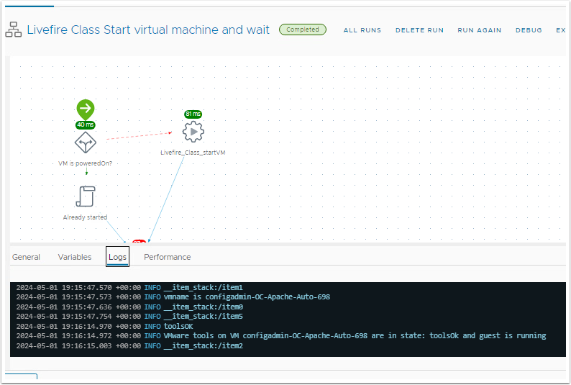

## PREREQUISITES

## 4. Creating a vRSLCM Configuration Using REST APIs in Orchestrator

## 5. Testing vRSLCM Content Management

## VCF Convert and Import

* VCF Convert and Import iSIMs

## VCF Convert and Import iSIMs

